

DIVERSIFICATION APPLICATIONS
IN
PORTFOLIO MANAGEMENT

NEETA BANTHIA
ROLL NO: CCCC/CCCC/0001

SPECIALIZATION: FINANCE MANAGEMENT

WELINGKAR INSTITUTE OF MANAGEMENT DEVELOPMENT & RESEARCH

Year of Submission: March, 2011

APPENDIX – I

CERTIFICATE FROM THE GUIDE

This is to certify that the Project work titled DIVERSIFICATION APPLICATIONS IN PORTFOLIO MANAGEMENT. Is a bonafide work carried out by Neeta Banthia # CCCCC/CCCC/00001
a candidate for the Post Graduate Diploma examination of the Welingkar Institute of
Management under my guidance and direction

SIGNATURE OF GUIDE

NAME : Atanu Maity

DESIGNATION: Manager, Projects & Logistics

ADDRESS : Mumbai

DATE: 02-05-2012
PLACE: MUMBAI

PREFACE
Many people consider investing to be a daunting activity. They are bewildered by the profusion and proliferation of investment alternatives, rattled by the fluctuations in financial prices, overwhelmed by the presence of mighty institutional investors, confused by exotic instruments and complicated investment strategies, confused by the intricacies of the tax system, and exasperated by the financial scams that periodically rock market.
Notwithstanding these concerns, investing can be fairly manageable, rewarding, and enjoyable experience, if we adhere to certain principles and guidelines. By this we can expect and hope to maximize our returns by diversifying our investments into suitable portfolios. For this, each and every investor has to be well educated about economy, investment options, market conditions and its consequences.
The main objective is to select the suitable investment criteria like if we want better returns, or consider risk factors, or liquidity or safety of principal. By this we can set our portfolio objectives and construct our portfolio according to our needs and manage it with respect to the market conditions and the securities fairing in the market.
ACKNOWLEDGEMENT
I extend my special gratitude to my Thesis Guide Mr. Atanu Maity for supporting me through out this project.
I wish to acknowledge my sincere gratitude and indebtedness to my thesis guide Dr. XXXXX XXXXX and Prof. XXXX XXXXX of XXXXX Institute of Management Studies, Mumbai for their valuable guidance and constructive suggestions in the preparation of thesis

I extend my gratitude to all my colleagues for their encouragement, support, guidance and assistance for preparing the thesis

Neeta Banthia

Table of Content

EXECUTIVE SUMMARY 7
HYPOTHESIS STATEMENT 8
Null Hypothesis: 8
Alternate Hypothesis: 8
REVIEW OF LITERATURE 9
3.1 PORTFOLIO 9
3.2 RISK 9
3.3 INVESTMENT 11
3.4 OPTIMAL PORTFOLIO 17
3.5 CAPITAL ASSET PRICING MODEL (CAPM): 19
3.7 PORTFOLIO CONSTRUCTION: 21
3.8 PORTFOLIO OBJECTIVES: 22
3.10 IMPORTANCE OF DIVERSIFICATION 29
3.12 SOURCES OF INFORMATION: 31
3.13 THE ROLE OF REAL ASSETS: 35
3.14 PORTFOLIO MANAGEMENT 42
3.16 PERFORMANCE EVALUATION 46
3.17 IMPORTANCE OF MEASURING PORTFOLIO RISK 46
3.18 MODELS 47
3.19 POST-MODERN PORTFOLIO THEORY 48
SECONDARY DATA 51
4.1 POINTS TO REMEMBER IN EQUITY INVESTING: 51
4.2 ELECTING FUNDS BASED ON PAST PERFORMANCE IS RISKY 51
4.3 INVESTOR WORKFLOW CYCLE: 52
4.4 KEY TO MAXIMIZE RETURNS 53
4.5 TIPS TO HELP BUILD A DEBT PORTFOLIO 53
4.6 SRI (SOCIALLY RESPONSIBLE INVESTING) 55
4.7 MANAGE RISK WITH BALANCED PORTFOLIO 55
4.8 MID-CAP STOCKS (A Portfolio-booster, but tread with care) 57
4.9 BUY AND HOLD OR QUIT AND FOLD 57
4.10 MOVE YOUR MONEY, MANAGE IT BETTER 58
4.11 SEEKING THE RIGHT BALANCE 59
4.12 THE IMPORTANCE OF ASSET ALLOCATION 60
4.13 COMMON MISTAKES THAT CARELESS INVESTORS MAKE 61
4.14 INVESTORS BET ON MULTINATIONAL COMPANIES FOR BIG RETURNS 63
PRIMARY DATA 64
SELECTION OF THE SAMPLE 64
DATA ANALYSIS 86
CONCLUSIONS & RECOMMENDATIONS 87
GLOSSARY 91
Bibliography 94

EXECUTIVE SUMMARY

An investment is a sacrifice of current money or other resources for future benefits. Numerous avenues of investment are available today. The two key aspects of any investment are time and risk. Very broadly, the investment process consists of two tasks. The first task is security analysis which focuses on assessing the risk and return characteristics of the available investment alternatives. The second task is portfolio selection which involves choosing the best possible portfolio from the set of feasible portfolios.
Construction of portfolio is only part of the battle. Once it is built, the portfolio needs to be maintained. The market values, needs of the beneficiary, and relative merits of the portfolio components can change over time. The portfolio manager must react to these changes. Portfolio management usually requires periodic revision of the portfolio in accordance with a predetermined strategy.
The type of sampling technique used is Simple Random Sampling wherein a questionnaire was prepared and distributed to the retail investors. The investor’s profile is based on the results of a questionnaire that the Investors completed. The Sample consists of 50 retail investors from various backgrounds. The target customers were only the retail investors who invest in various avenues so as to know about their knowledge and concern regarding the economy, principal invested, investment options, market conditions etc.
According to the opinion of these investors interpretation has been done and there has been findings and conclusion along with some recommendations.

HYPOTHESIS STATEMENT
A hypothesis is a proposed explanation for an observable phenomenon. The term derives from the Greek word – hypotithenai meaning "to put under" or "to suppose”.
For the present study it is proposed to have following hypothesis:

Null Hypothesis:
Most of the investors prefer return as their investment criteria rather than risk, liquidity and safety of principal etc.

Alternate Hypothesis:
Most of the investors don’t prefer return as their investment criteria rather go for either risk or liquidity or safety of principal etc.

REVIEW OF LITERATURE

3.1 PORTFOLIO
A portfolio is an appropriate mix of or collection of investments held by an institution or a private individual. It is a collection of securities, since it is rarely desirable to invest the entire funds of an individual or an institution in a single security.
Portfolio analysis considers the determination of future risk and return in holding various blends of individual securities.
Portfolio expected return is a weighted average of the expected return of individual securities but portfolio variance, in short contrast, can be something less than a weighted average of security variances.
As a result an investor can sometimes reduce portfolio risk by adding security with greater individual risk than any other security in the portfolio. This is because risk depends greatly on the co-variance among return of individual securities.
Since portfolios expected return is a weighted average of the expected return of its securities, the contribution of each security to the portfolio’s expected returns depends on its expected returns and its proportionate share of the initial portfolio’s market value.

3.2 RISK
Risk is a concept that denotes a potential negative impact to an asset or some characteristic of value that may arise from some present process or future event. In everyday usage, risk is often used synonymously with the probability of a known loss. Risk is uncertainty of the income/capital appreciation or loss of the both.
The total risk of an individual security comprises two components, the market related risk called Systematic Risk also known as undiversifiable risk and the unique risk of that particular security called Unsystematic Risk or diversifiable risk.

3.2.1 TYPES OF RISK
Modern portfolio theory looks at risk rom a different perspective. It divides total risk as follows, Total Risk = Unique Risk + Market Risk
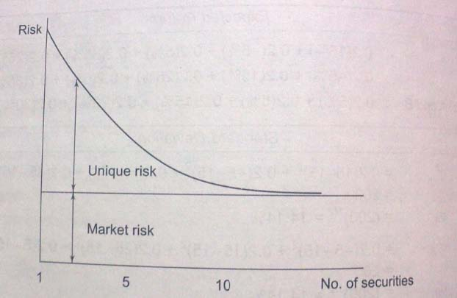
FIGURE 1: Relationship between diversification and risk
The Unique Risk of a security represents that portion of its total risk which stems from firm-specific factors like the development of a new product, a labour strike, or the emergence of a new competitor. Events of this nature primarily affect the specific firm and not all firms in general. Hence, the unique risk of a stock can be washed away by combining it with other stocks. In a diversified portfolio, unique risks of different stocks tend to cancel each other – a favourable development in one firm may offset an adverse happening in another and vice versa. Hence, unique is also referred to as diversifiable risk or unsystematic risk.
The Market Risk of a security represents that portion of its risk which is attributable to economy-wide factors like the growth rate of GDP, the level of government spending, money supply, interest rate structure, and inflation rate. Since these factors affect all firms to a greater or lesser degree, investors cannot avoid the risk arising from them, however diversified their portfolios may be. Hence, it is also referred to as systematic risk (as it affects all securities) or non-diversifiable risk.

3.3 INVESTMENT
Investment may be defined as an activity that commits funds in any financial form in the present with an expectation of receiving additional return in the future. The expectations bring with it a probability that the quantum of return may vary from a minimum to a maximum. This possibility of variation in the actual return is known as investment risk. Thus every investment involves a return and risk.
Investment is an activity that is undertaken by those who have savings. Savings can be defined as the excess of income over expenditure. An investor earns/expects to earn additional monetary value from the mode of investment that could be in the form of financial assets.
The three important characteristics of any financial assets are:
Return – the potential return possible from an asset
Risk – the variability in returns of the asset from the chances of its value going down/up.
Liquidity – the ease with which an asset can be converted into cash.
Investors tend to look at t these three characteristics while deciding on their individual preference [pattern of investments. Each financial asset will have a certain level of each of these characteristics.

3.3.1 INVESTMENT ALTERNATIVES:
An investor has wide range of investment avenues such as:
Non – Marketable Financial Assets
A good portion of financial assets is represented by non – marketable Financial Assets. They can be classified into various categories such as:

Bank deposits,
Post office deposits,
Company deposits and
Provident fund deposits.

Equity Shares
Equity shares represent ownership capital. An equity shareholder has an ownership stake in the company i.e. he / she has a residual interest in income and wealth. Equity shares are classified into broad categories by stock market analysts such as:
Blue chip Shares,
Growth Shares,
Income Shares,
Cyclical Shares and
Speculative Shares.

Bonds
Bonds or Debentures represent long-term debt instruments. The issuer of a bond promises to pay a stipulated stream of cash flow. Bonds may be classified into the following categories such as:
Government Securities,
Savings Bonds,
Government Agency Securities,
PSU Bonds,
Debentures of Private Sector Companies and
Preference Shares.

Money Market Instruments
Debt Instruments which have a maturity of less than one year at the time of issue are called money market instruments. The important money market instruments are:

- Treasury bills,
- Commercial paper and
- Certificate of deposit.

Mutual Fund Schemes
Instead of directly buying equity shares and / or fixed income instruments we can participate in various schemes of mutual funds which, in turn, invest in equity shares and fixed income securities. There are three broad types of mutual fund schemes such as:

- Equity Schemes
- Debt Schemes
- Balanced Schemes

Life Insurance Policies
Life Insurance may also be viewed as an investment. Insurance premiums represent the sacrifice and the assured sum, the benefit. The important types of insurance policies are:
- Endowment assurance policy
- Money back policy
- Whole life policy
- Term assurance policy

Real Estate
For the bulk of the investors the most important asset in their portfolio is a residential house. In addition to a residential house, the more affluent investors are likely to be interested in the following types of real estate:

- Agricultural Land
- Semi – Urban Land
- Commercial Property
- A resort home
- A second house

Precious Objects
Precious objects are items that are generally small in size but highly valuable in monetary terms. The most important precious objects are:

- Gold and Silver
- Precious Stones
- Art Objects

FINANCIAL DERIVATIVES
A financial derivative is an instrument whose value is derived from the value of an underlying asset. The most important financial derivatives from the point of view of investors are:

- Options
- Futures

3.3.2 CRITERIA FOR EVALUATION::
For evaluating an investment avenue, the following criteria are relevant:
Rate Of Return
The rate of return on an investment for a period (usually a period of one year) is defined as follows:
Rate of return = Annual Income + (Ending Price – Beginning Price) / Beginning Price

Risk
The rate of return from investments like equity shares, real estate, silver, and gold can vary rather widely. The risk of an investment refers to the variability of its rate of return like how much do individual outcomes deviate from the expected value? There are some measures which are used to measure risk such as:

- Dispersion
- Variance
- Standard Deviation
- Beta (This reflects how volatile is the return from an investment relative to market swings.)

Marketability
An investment is highly marketable or liquid if,

- It can be transacted quickly
- The transaction cost is low
- The price change between two successive transactions is negligible. The liquidity of a market may be judged in terms of its depth, breadth, and resilience. Depth refers to the existence of buy as well as sell orders around the current market price. Breadth implies the presence of such orders in substantial volume. Resilience means that new orders emerge in response to price changes. Investors value liquidity because it allows them to change their minds. They can correct errors they may have made quickly and cheaply. Further, they can easily modify their investments in line with changing circumstances and objectives.

Tax Shelter
Some investments provide tax benefits and some do not. Tax benefits are of three types:

- Initial Tax Benefit: It refers to the tax relief enjoyed at the time of investment.
- Continuing Tax Benefit: It represents the tax shield associated with the periodic returns from the investment.
- Terminal Tax Benefit: It refers to relief from taxation when an investment is realized or liquidated.

Convenience
It refers to the ease with which the investment can be made and looked after. The degree of convenience associated with investments varies widely.

3.3.3 COMMON ERRORS IN INVESTMENT MANAGEMENT:
Investors appear to be prone to the following errors in managing their investments. Some of the common errors are:
 Inadequate comprehension of return and risk
- Vaguely formulated investment policy
- Naïve extrapolation of the past
-  Cursory decision making
- Untimely entries and exits
- High costs
-  Over – diversification and under – diversification
- Wrong attitude toward losses and profits

3.3.4 QUALITIES FOR SUCCESSFUL INVESTING
The game of investment requires certain qualities and virtues on the part of the investors, to be successful in the long run. The following qualities which are mostly found are:
- Contrary thinking
- Patience
- Composure
- Flexibility and openness
- Decisiveness

3.4 OPTIMAL PORTFOLIO
Once the efficient frontier is delineated, the optimal portfolio has to be determined. To determine the optimal portfolio on the efficient frontier, the investor’s risk – return tradeoff must be known. Figure 2 below represents two illustrative indifference curves which reflect risk – return tradeoff functions. All points lying on an indifference curve provide the same level of satisfaction. The indifference curves Ip and Iq represent the risk – return tradeoffs of two hypothetical investors, P and Q. Both P and Q, like most investors, are risk – averse. They want higher returns to bear more risk. Q is however more risk – averse than P. Q wants a higher expected return for bearing a given amount of risk as compared to P. In general, the steeper the slope of the indifference curve, the greater the degree of risk aversion.

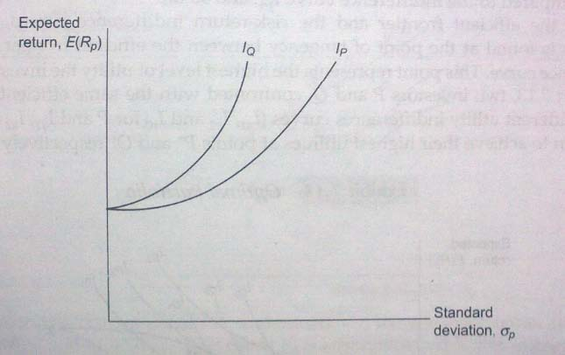
FIGURE 2: Risk-Return Indifference Curves
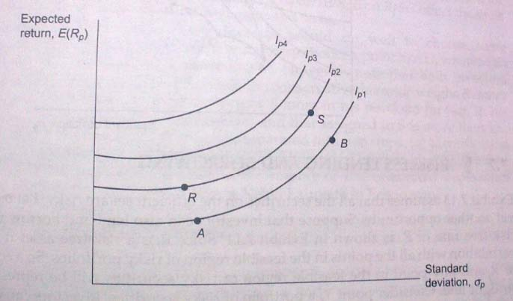
FIGURE 3: Utility Indifference Curves

Figure 3 shows the indifference map for P. In this figure, four risk – return indifference curves, Ip1, Ip2, Ip3, and Ip4 are shown. All the points lying on a given indifference curve offer the same level of satisfaction. For example, points A and B, which lie on the indifference curve Ip1 offer the same level of satisfaction; likewise, points R and S, which lie on the indifference curve Ip2, offer the same level of satisfaction. The level of satisfaction increases as one moves leftward. The indifference curve Ip2, represents a higher level of satisfaction as compared to the indifference curve Ip1; the indifference curve Ip3 represents a higher level of satisfaction when compared to the indifference curve Ip4; and so on.
Given the efficient frontier and the risk – return indifference curves, the optimal portfolio is found at the point of tangency between the efficient frontier and a utility indifference curve. This point represents the highest level of utility the investor can reach. In figure 4 two investors P and Q, confronted with the same efficient frontier, but having different utility indifference curves (Ip1, Ip2 and Ip3 for P and Iq1, Iq2 and Iq3 for Q) are shown to achieve their highest utilities at points P* and Q* respectively.
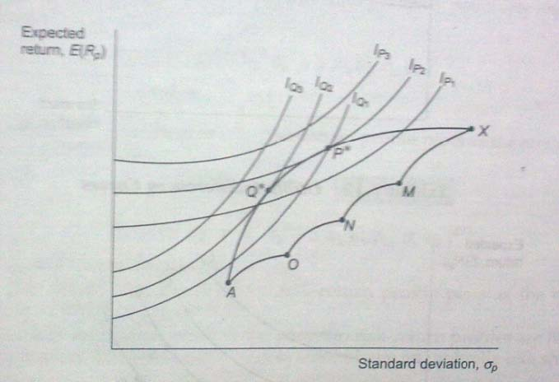
FIGURE 4: Optimal Portfolio

3.5 CAPITAL ASSET PRICING MODEL (CAPM):
The CAPM predicts the relationship between the risk of an asset and its expected return. This relationship is important in two important ways:
- It produces a benchmark for evaluating various investments. For example, when the investors analyze a security they are interested in knowing whether the expected return from it is in line with its fair return as per the CAPM.
- It helps the investors make a guess about the return that can be expected from an asset that has not yet been traded in the market.

3.5.1 BASIC ASSUMPTIONS OF CAPM:
- The CAPM is based on the following assumptions: ➢ Individuals are risk averse.  Individuals seek to maximize the expected utility of their portfolio over a single period planning horizon.
-  Individuals have homogenous expectations they have identical subjective estimates of the means, variances, and covariance’s among returns.
-  Individuals can borrow and lend freely at a riskless rate of interest. ➢ The market is perfect, there are no taxes, there are no transaction costs, securities are completely divisible, and the market is competitive.
- The quantity of risky securities in the market is given.

3.7 PORTFOLIO CONSTRUCTION:

3.7.1 UNDERSTANDING PORTFOLIO CONSTRUCTION METHODOLOGY
The methodology used by fund managers to construct their portfolios will very much depend on the type of fund that they are managing, as well as the style of management that they use. Although there are many general funds, such as segregated pension funds, that invest globally, there is a continuing trend towards specialization in particular funds, such as segregated pension funds, that invest globally, there is a continuing trend towards specialization in particular markets, and each market will have its own principal considerations.
Equity management involves an element of asset allocation, either to countries managed by the European, Far Eastern Latin America or Emerging Markets desks, or to industries within single countries, especially within the UK. Having said this internationalization of many companies in recent years has resulted in fund managers looking at industry grouping irrespective of the country in which the corporate is based.

Since firms derive an increasing proportion of their earnings from countries outside their domicile, it is becoming less and les relevant analyses them on the basis of economic prospects for that country (e.g. GDP growth etc), More relevant are the issues facing each industry.
The number of different influences on a portfolio is quite diverse. This creates the need for a broad range of different analyses so that the fund manager can look at his portfolio broken down in different ways, particularly useful are analyses of portfolio giving the weights allocated to each category, especially where these weights are compared to the constituents of the index used as part or all of the fund’s bench mark.
Other Analyses are: Equities are sensitive to a number of different factors affecting their market prices in the short, medium or long term. This means that the fund manager needs to look at his portfolio, and the securities held in them, from a number of different perspectives and involves assimilating the huge quantities of data available to fund managers, sourced from external brokers as well as their own firm’s analysts. The key is the interpretation of the data: What does the news imply for a security or overall industry grouping?
Portfolio level analysis includes the following:
Fund Break down By:
Company Size: In an economic upswing smaller companies may grow faster than larger firms, whilst in a recession investors may prefer larger, more resilient (through cash availability or diversification) companies.

Economics theme: E.g. Sensitive to oil prices, interest rates, factors affecting other economics in to products are sold. Over all portfolio factors such as the fund’s beta can also provide useful risk information. As with most types of fund level analysis, the comparison of the funds against the benchmark is the most useful. Other security level analysis includes the price to earning ratio growth which is a dynamic measure of a trend of changing value (if we are a value -style manager) or changing growth (if we are growth manager).

3.8 PORTFOLIO OBJECTIVES:
Before selecting the appropriate objectives, several preconditions must be met. They are:
- An assessment of the existing situation is necessary like, current needs of the portfolio beneficiary, drastic changes in the composition of the portfolio (especially the level of income generated) may not be feasible.
- A second concern is the investment horizon considering if the portfolio is part of a pension fund’s assets (the investment horizon is very long term), the ups and downs of the market etc.
-  Liquidity needs and ethical considerations established by the fund’s owner.
- Some of the distinct portfolio objectives are:
- Stability Of Principal
When someone says, “ I don’t want any chance of losing the money I invest”, the fund manager should interpret this person’s objective as stability of principal. This is the most conservative portfolio objective, and over the long run, it will generate the most modest return. The emphasis here is on preserving the “original” value of the fund. When stability of principal is the objective, the appropriate investment vehicles include any of the money market instruments and bank certificates of deposit.

- Income
The income objective differs from stability of principal in that there is no specific proscription (forbid) against periodic declines in principal value. The consequences of the fluctuations in market may vary. When income is chosen objective, appropriate investments include corporate bonds, government bonds, government agency securities, preferred stock, and some common stock.

- Growth of Income
The time value of money is one of the key concepts in finance. Rupees today are worth more than an equal number of rupees ay any point in the future. This objective usually involves a reduced initial income payout, but one that grows over time and eventually overtakes the level amount from an income objective. The client and the fund manager should clearly understand the difference between income and growth of income as objectives. An income objective seeks to generate as much current income as possible within the risk parameters established. Initially this amount will be higher than that generated by a portfolio seeking growth of income. Eventually, though, income from the latter portfolio will overtake that generated by the former.
The key point is a growth-of-income objective requires the fund manager to seek some capital appreciation in the original principal. This means that some of the fund must be invested in equity securities. The common stocks purchased may generate some income from dividends, but the bulk of the income will come from fixed-income securities such as long-term bonds.

- Capital Appreciation
Occasionally it is not important that a portfolio generate any income at all. A retired couple, for instance, might receive pension and Social Security Checks that are sufficient to finance their retirement life-style. If these people have an investment portfolio, they might be more interested in having it continue to grow in value rather than in getting additional income from it.
There is also an income tax consideration. Interest or dividends received are immediately taxable. Capital gains are not taxed until they are actually realized. This means that unless income is actually needed, a rupee capital gain is really worth more than a rupee of income. The unrealized capital gains are not taxed, whereas dividend or interest income is. Taxes can be deferred for many years by successful long-term growth stock investing.

3.8.1 THE IMPORTANCE OF PRIMARY AND SECONDARY OBJECTIVES:
Establishing the primary objective of the portfolio is a major accomplishment for the fund manager and the fund beneficiary. But it is also prudent and enormously helpful to establish a secondary objective in addition to a primary objective. The secondary objective indicates what is next in importance after specification of primary objective. The portfolio manager has to decide what percentage of the investment funds to put into equities. Most of the remainder will go into debt securities, real assets or hard assets.
Consider a person who wants that current income should be the primary objective of the portfolio. This could be accomplished by investing in money market securities, in long-term debt, or in dividend-producing common stock. The client might make statements like, “I really don’t want to take any risk with this money” or “Is there any chance I am going to lose any of this?”. In this case, stability of principal is probably the client’s secondary objective.
In contrast, the client might ask, “Is the income I get going to keep up with inflation?”. This implies growth of income as a secondary objective. To accomplish this, the fund manager must attempt to get some appreciation in the principal of the fund, and this requires a greater investment in equities

3.9 4 STEPS TO BUILDING A PROFITABLE PORTFOLIO:
In today's financial marketplace, a well-maintained portfolio is vital to any investor's success. As an individual investor, we need to know how to determine an asset that best conforms to our personal investment goals and strategies. In other words, our portfolio should meet our future needs for capital and give us peace of mind. Investors can construct portfolios aligned to their goals and investment strategies by following a systematic approach. Here we go over some essential steps for taking such an approach.

Step 1: Determining the Appropriate Asset Allocation
Ascertaining our individual financial situation and investment goals is the first task in constructing a portfolio. Important items to consider are age, how much time we have to grow our investments, as well as amount of capital to invest and future capital needs. A single college graduate just beginning his or her career and a 55-year-old married person expecting to help pay for a child's college education and plans to retire soon will have very different investment strategies.
A second factor to take into account is our personality and risk tolerance. Are we the kind of person who is willing to risk some money for the possibility of greater returns? Everyone would like to reap high returns year after year, but if we are unable to sleep at night when our investments take a short-term drop, chances are the high returns from those kinds of assets are not worth the stress.
As we can see, clarifying our current situation and our future needs for capital, as well as our risk tolerance, will determine how our investments should be allocated among different asset classes. The possibility of greater returns comes at the expense of greater risk of losses (a principle known as the risk/return tradeoff) – we don't want to eliminate risk so much as optimize it for our unique condition and style. For example, the young person who won't have to depend on his or her investments for income can afford to take greater risks in the quest for high returns. On the other hand, the person nearing retirement needs to focus on protecting his or her assets and drawing income from these assets in a tax-efficient manner.
Conservative Vs. Aggressive Investors
Generally, the more risk we can bear, the more aggressive our portfolio will be, devoting a larger portion to equities and less to bonds and other fixed -income. Conversely, the less risk that's appropriate, the more conservative our portfolio will be. Here are two examples: one suitable for a conservative investor and another for the moderately aggressive investor.
The main goal of a conservative portfolio is to protect its value. The allocation shown above would yield current income from the bonds, and would also provide some long-term capital growth potential from the investment in high-quality equities.

A moderately aggressive portfolio satisfies an average risk tolerance, attracting those willing to accept more risk in their portfolios in order to achieve a balance of capital growth and income.
Step 2: Achieving the Portfolio Designed in Step 1
Once we have determined the right asset allocation, we simply need to divide our capital between the appropriate asset classes. On a basic level, this is not difficult: equities are equities, and bonds are bonds.
But we can further break down the different asset classes into subclasses, which also have different risks and potential returns. For example, an investor might divide the equity portion between different sectors and market caps, and between domestic and foreign stock. The bond portion might be allocated between those that are short term and long term, government versus corporate debt and so forth.
There are several ways we can go about choosing the assets and securities to fulfill our asset allocation strategy:
- Stock Picking: Choose stocks that satisfy the level of risk we want to carry in the equity portion of our portfolio -sector, market cap and stock type are factors to consider. Analyze the companies using stock screeners to shortlist potential picks, than carry out more in-depth analyses on each potential purchase to determine its opportunities and risks going forward. This is the most work-intensive means of adding securities to our portfolio, and requires us to regularly monitor price changes in our holdings and stay current on company and industry news.
- Bond Picking: When choosing bonds, there are several factors to consider including the coupon, maturity, the bond type and rating, as well as the general interest rate environment.
- Mutual Funds: Mutual funds are available for a wide range of asset classes and allows us to hold stocks and bonds that are professionally researched and picked by fund managers. Of course, fund managers charge a fee for their services, which will detract from our returns. Index funds present another choice; they tend to have lower fees because they mirror an established index and are thus passively managed.

- Exchange-Traded Funds (ETFs): If we prefer not to invest with mutual funds, ETFs can be a viable alternative. We can basically think of ETFs as mutual funds that trade like stocks. ETFs are similar to mutual funds in that they represent a large basket of stocks -usually grouped by sector, capitalization, country and the like -except that they are not actively managed, but instead track a chosen index or other basket of stocks. Because they are passively managed, ETFs offer cost savings over mutual funds while providing diversification. ETFs also cover a wide range of asset classes and can be a useful tool for rounding out our portfolio.
Step 3: Reassessing Portfolio Weightings
Once we have an established portfolio, we need to analyze and rebalance it periodically because market movements may cause our initial weightings to change. To assess our portfolio's actual asset allocation, quantitatively categorize the investments and determine their values' proportion to the whole.
The other factors that are likely to change over time are our current financial situation, future needs and risk tolerance. If these things change, we may need to adjust our portfolio accordingly. If our risk tolerance has dropped, we may need to reduce the amount of equities held. Or perhaps we are now ready to take on greater risk and our asset allocation requires that a small proportion of our assets be held in riskier small – cap stocks.
Essentially, to rebalance, we need to determine which of our positions are overweighted and underweighted. For example, say we are holding 30% of our current assets in small-cap equities, while our asset allocation suggests we should only have 15% of our assets in that class. Rebalancing involves determining how much of this position we need to reduce and allocate to other classes.
Step 4: Rebalancing Strategically
Once we have determined which securities we need to reduce and by how much, decide which underweighted securities we will buy with the proceeds from selling the overweighted securities. To choose our securities, the approaches discussed in Step 2 are used.

When selling assets to rebalance our portfolio, a moment is taken to consider the tax implications of readjusting our portfolio. Perhaps our investment in growth stocks has appreciated strongly over the past year, but if we were to sell all of our equity positions to rebalance our portfolio, we may incur significant capital gains taxes. In this case, it might be more beneficial to simply not contribute any new funds to that asset class in the future while continuing to contribute to other asset classes. This will reduce our growth stocks' weighting in our portfolio over time without incurring capital gains taxes.
At the same time, the outlook of our securities has to be always considered. If we suspect that those same overweighted growth stocks are ominously ready to fall, we may want to sell in spite of the tax implications. Analyst opinions and research reports can be useful tools to help gauge the outlook for your holdings. And tax-loss selling is a strategy we can apply to reduce tax implications.

3.10 IMPORTANCE OF DIVERSIFICATION
Throughout the entire portfolio construction process, it is vital that we remember to maintain our diversification above all else. It is not enough simply to own securities from each asset class; we must also diversify within each class. Ensure that our holdings within a given asset class are spread across an array of subclasses and industry sectors.
As already mentioned, investors can achieve excellent diversification by using mutual funds and ETFs. These investment vehicles allow individual investors to obtain the economies of scale that large fund managers enjoy, which the average person would not be able to produce with a small amount of money.
3.11 SECURITY SCREENING:
Security screening is an important part of the portfolio construction process, but one about which relatively little is written. Picking stocks is an art rather than a science; there is no best way to do the screening, nor is there even a right or wrong way. Everyone who participates in the capital markets uses some type of screen –a procedure for reducing a large set of alternatives to a more manageable number.
3.11.1 WHY SCREENING IS NECESSARY?
The primary reason why screening is necessary is the limited amount of time
available for making decisions. In the investment business, there is no time to analyze
every security and process the associated information.
3.11.2 WHAT CONSTITUTES A GOOD SCREEN?
The idea of screening is appealing and most screens are logical. There are some
sections that discuss some characteristics of a good screen:

-  Ease Of Administration
Managerial aids are only useful if they are used. For instance, I might be asked to find a thinly traded stock that looks appealing. Thin trading is a term that refers to a security with a small number of shareholders and a general lack of trading volume. I could begin by identifying firms with fewer than 5000 shareholders. I would have to look up each individual company in one of the Standard & Poor’s or Moody’s publications. A better approach would be to check trading volume figures. I could take a random copy of the Wall Street Journal, run down stock listings on the various exchanges and the OTC market, and note firms with a previous day’s volume of less than, say, 1000 shares. Thin trading cannot be precisely defined, but volume this small certainly qualifies as thin. This method would be much more efficient than checking the number of shareholders, and it would accomplish essentially the same purpose. From the list of thinly traded securities I identified, I could apply further screens as I sought an attractive investment.

- Relevance And Appropriateness
Screens should also logically have something to do with the ultimate objective. Someone might say, “I am going to invest in a good company whose name begins with the letter A.” This probably makes no sense. Now considering a slightly different situation wherein one wants to identify a promising company but do not want to spend hours poring through the financial pages. He might instead decide to start at the top of the NYSE listing and find something in the early of the alphabet, or in the middle. This latter technique is more logical than the former. The point is that the first letter in a company’s name is not really a decision variable, should not be material, and is consequently an inappropriate screening device.

- Acceptance By The User
Screens lose much of their value if the people who are affected by the screen fundamentally disagree with it.
3.12 SOURCES OF INFORMATION:
There are several well-known and readily accessible sources of information that can be very helpful in gathering some quick information about unfamiliar securities. These are:

- Value Line:
One of the best-known subscription services is the Value Line Investment Survey. This weekly publication from value line, Inc., follows 1700 different common stocks and rates them in two categories:
  - Timeliness refers to precisely what one would expect i.e., the advisability of buying this stock now.
  - Safety refers to the confidence the Value Line analysts have in their forecasts about the firm. Value Line assigns a ranking in each of these categories according to the schedule listed in the table below

RANKING | NUMBER OF STOCKS WITH THIS RANKING | MEANING
1 | 100 | Best
2 | 300 | Above average
3 | 900 | Average
4 | 300 | Below average
5 | 100 | Worst

TABLE 2: Value Line Ranking System

- Standard & Poor’s
Standard & Poor’s Corporation publishes a wide variety of reports on the economy, industries, and individual stocks. Two of these reports are especially useful to portfolio managers. These are:
  - Stock Report: The S&P Stock Report is a one-page document that contains a surprisingly thorough description of a company and an estimate of what the future holds for it. These reports are updated quarterly and are housed in a loose-leaf binder in most public libraries. The report contains financial statement information in addition to dividend payment dates, beta, and other risk measures.
  - Stock Guide: The S&P Stock Guide is published monthly and contains summary statistics on thousands of common stocks, warrants, and mutual funds. This publication is small enough to be carried conveniently in a briefcase or coat pocket. Many brokers receive a dozen or so of these each month and provide them to their customers who request them. Although they are published monthly, a Stock Guide that is several months old is still quite useful.

  - Moody’s Investment Service
Another widely used set of investment information are the volumes published by Moody’s Investment Service. These volumes are collectively called “Moody’s Manuals”. Some of the individual volumes are:
- Moody’s Manual of Investments: Most needs for quick information can be satisfied by either the Stock Report or the Stock Guide, but at times we may not find what we need in these two sources. Moody’s Manual of Investments is a good place to turn next. This publication contains several sets of volumes: one set of industrial firms, one on municipals and governments, one on OTC industrials, one on public utilities, and one on transportation issues.
An especially common problem arises when we seek information about a company that, unknown to us, doesn’t have stock that trades publicly. The firm may be a subsidiary of another company or may not be publicly held. The blue pages of Moody’s Manuals contain a cross-reference of subsidiaries. For instance, we will find that Pizza Hut is a subsidiary of Pepsico.
Moody’s Manuals also contain more detailed news reports about a firm, more detailed financial statements, and other relevant information that cannot be included in the Stock Report because of space limitations. This information source is a heavy book, is expensive to acquire, and cannot be conveniently be taken outside.
- Moody’s Dividend Record: When it is necessary to investigate the recent dividend history of a company (payment dates, ex-dividend dates, and so on), Moody’s Dividend Record is one of the most convenient places to get this information quickly.

-  Brokerage Information
A final information source available is through our broker. All full-service brokerage firms (and some discount firms) have in-house research capability. We can request a report on a particular company or give our broker a list of securities of interest and ask that we receive reports on these firms as they are produced.

3.13 THE ROLE OF REAL ASSETS:

3.13.1 INTRODUCTION:
Modern investment decisions involve a lot more than traditional stocks and bond issues. A general lack of understanding of concepts like duration and or the utility of futures market products contributed to the demise of many savings and loans. Today’s executives in any business must keep pace with changes in the industry if they want to survive. There are two assets timberland and gold, which are nontraditional in the sense that most portfolio managers have limited understanding of them. Not every portfolio can, or should, invest in these.
Before looking at specific information about these investment alternatives, it is useful to know the distinction between financial assets and real assets. Most portfolios are invested in financial assets. These are familiar securities such as shares of common stock, corporate bonds, and bank certificates of deposit. The key characteristic of a financial asset is that for each such asset, somewhere out there a corresponding liability exists. Financial assets are on two balance sheets: as an asset for someone and as a liability for someone else. Real assets, in contrast, do not have a corresponding liability, although one may be created to finance the purchase of the asset. Real estate purchases are normally leveraged.

3.13.2 REAL ESTATE IN GENERAL:
INVESTMENT CHARACTERISTICS
Real estate is widely acclaimed as a good investment. Most real estate cite three fundamental characteristics of land. Land is immobile, indestructible, and nonfungible (means every plot is unique). Land obviously cannot be moved. Land is widely considered a long-term investment, although it does not have to be. Timberland buyers often hope to liquidate the timber and sell the “carcass” over a fairly short time horizon. The majority of institutional landowners are looking for a mix of annual cash flows and long-term capital appreciation. Five general categories of real estate are shown in table below:

Residential | Commercial | Industrial | Farm | Special Purpose
Owner | Office | Light | Timberland | Cemeteries
occupied | buildings | manufacturing
Rental | Store properties | Heavy manufacturing | Pastureland | Churches
 | Lofts | Mining | Ranches | Government properties
 | Theatres |  | Orchards | Golf courses
 | Garages |  | Farmland | Parks
 | Hotels and |  |  | Public building
 | motels |  |  | and streets

TABLE 3: Categories of real estate

3.13.3 DEVELOPED AND UNDEVELOPED PROPERTY
Real estate is often subdivided into developed property and undeveloped property. Developed property is land with improvements on it; undeveloped, or raw, land has no improvements. Developed property is generally purchased for its income-producing characteristics and for tax advantage stemming from depreciation of buildings on the land. Shopping malls, apartment complexes, and office buildings are good examples. Most real estate limited partnerships invest primarily in developed property.
The motives for the purchase of undeveloped property are more varied. They include outright speculation; timber, crop, or livestock production; and the actual production of subdivided lots of resale or development.

3.13.4 PENSION FUND INVESTMENT IN REAL ESTATE
In late 1989 the U.S. pension fund industry had approximately $72 billion invested in one form or another of real estate. By 1994, an additional $100 billion in new pension fund money is expected to enter the real estate market. Figure 7 shows the approximate distribution of pension fund real estate investments by type of asset.
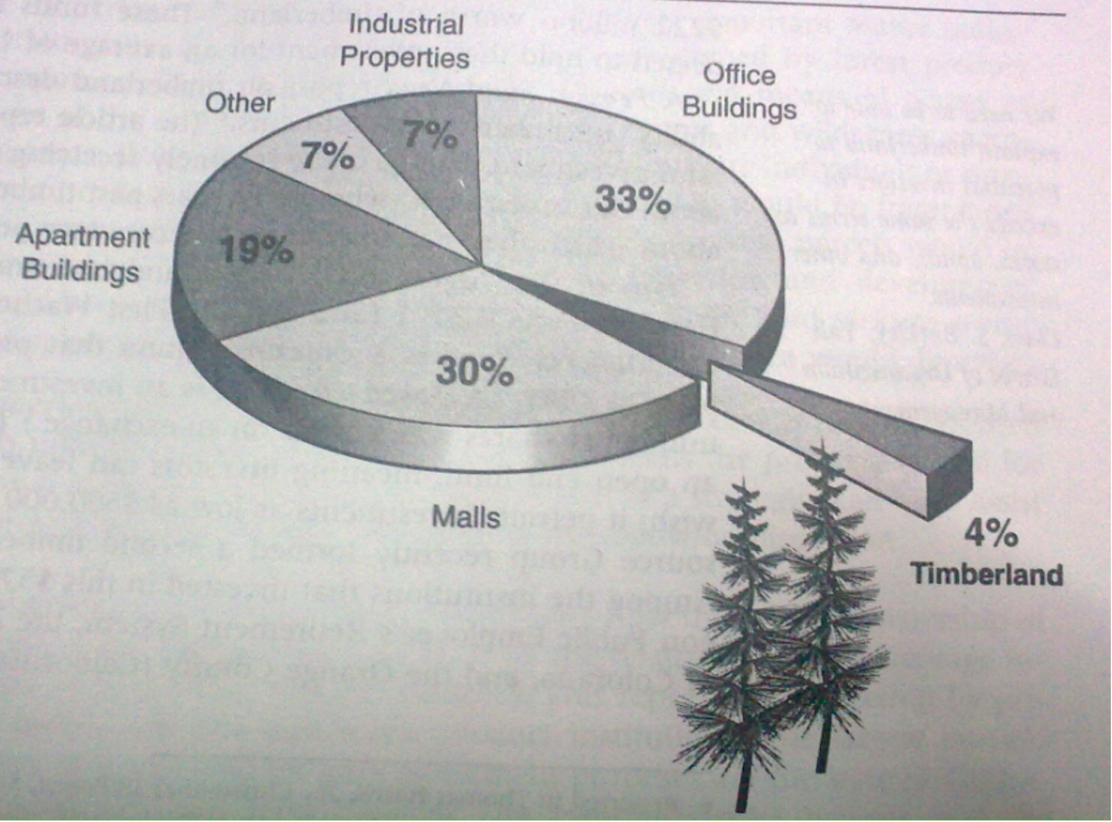
FIGURE 7: Pension fund investment in real estate
Pension funds often acquire real estate when their cash inflows are larger than expected. Timberland is considered by most people as a perfect example for

undeveloped property. What could be more undeveloped than the woods? Timberland as a pure investment, however, can definitely be income producing.

3.13.5 TIMBERLAND AS AN INVESTMENT AVENUE
Timberland is a little-known but very viable form of real estate for most large portfolios. There is real potential for this asset to account for a major share of the expected increased investment in real estate.

3.13.6 TIMBERLAND AS AN ASSET
The different motivations for timberland investment generally fall into one of three groups:
- Timberland As Collateral: The use of timberland as collateral has a long heritage. Life insurance companies and the Federal Land Bank both routinely secure loans, either partially or fully, with timberland, and they have done so for many years. In fact, the first leveraged buyout probably occurred with timberland, the forest itself being used as collateral for the loan used to acquire the land.
- Timberland As a Strategic Investment: Timberland serves as a strategic investment when owning it helps ensure the long-term viability of a company or reduces the volatility of its cash flows. This motivation is especially evident in regions where the forest industry is strong and depends heavily on assured raw material supplies.
- Timberland As a Pure Investment: The fund manager is most concerned with timberland as a pure investment. This means the property is held for its own investment merits rather than as a part of a strategic plan or to assist in project financing.

3.13.7 TIMBERLAND AS A PORTFOLIO COMPONENT
There is a growing interest in the risk-reduction potential that timberland offers. We have seen that portfolios should contain assets whose returns are poorly correlated. Low correlation reduces the volatility of a portfolio without necessarily affecting the expected level of return. Virtually all studies of timberland price behavior find very low or negative correlation between timberland and other investment alternatives. Table 8 shows the correlation coefficients of various investment alternatives.

Investment | Correlation Coefficient
Timberland | 1.0000
Residential housing | -0.0905
Farm real estate | 0.5612
S&P 500 index | -0.4889
OTC stocks | -0.4917
Preferred stock average | -0.3533
No-load mutual fund average | -0.6351
Municipal bonds | -0.0900
Treasury bills | 0.3118
Treasury notes | -0.2371
Long-term corporate bonds | -0.2704
Commodity futures average | 0.8988

TABLE 4: Timberland correlation coefficients

3.13.8 GOLD
In a nutshell, perhaps the most important general investment characteristic of gold is people buy it primarily because of the security it provides against times of trouble. Numerous factors can make gold an attractive investment. Like timberland, gold has historically demonstrated returns that are unrelated to the stock market as a whole. This makes gold a powerful diversifying agent in a portfolio.

Gold is a popular trading commodity among speculators because of its price volatility. It is popular with hedgers because of its risk-reduction characteristics. No one likes inflation. Historically, gold has been a useful inflation hedge, and an increase in the price of oil raises fears of inflation.

3.13.9 INVESTING IN GOLD
An individual or an institution can invest in gold in four principal ways:
- Bullion: The rare individual may have the money and inclination to buy gold bars (bullion) and stack them in basement. Smaller quantities may be stored in 1-ounce bars, in nuggets, or as gold dust. These investments may be exotic, but they have obvious shortcomings. First, there is a significant risk of theft. Second, they produce no income until sold. Third, they lack marketability.
- Gold Certificates: Investors also can purchase documents representing ownership of gold bullion that is kept by someone else on their behalf. A number of banks in the United States and Canada issue these gold certificates, which are obligations of the issuer to deliver gold upon demand. If we purchase these, we can actually take delivery any time we wish. Certificates are registered in our name, which adds a bit of security to the investment. Certificates may be readily sold back to the dealer from whom we bought them, although we will lose a few percentage points in the dealer’s bid-ask spread. The primary advantage of gold certificates over the bullion itself is convenience. We are freed from worry about storage, delivery, and insurance. These certificates do carry the risk that there is no gold backing them, but if we deal through a major bank or brokerage firm, this risk is minimal.
- Shares in Mining Companies: Perhaps the most popular form of gold ownership in the United States is through the purchase of shares in gold-mining companies, either directly or through a mutual fund. Owning shares has major advantages over other forms of ownership as shares are instantly marketable and can generate some income through dividends.

- Coins: Gold coins are popular with both collectors and gold speculators. It is important to distinguish between a coin’s intrinsic value and its numismatic value. A coin’s value intrinsic value is the higher of its bullion value or its fiat value (the value assigned to it by the issuing government). Collectors may be willing to pay more than the value of gold contained in a coin because the coin is rare or popular. Some people find it difficult to be both collectors and investors in gold.

3.14 PORTFOLIO MANAGEMENT
The technique of matching the assets of one’s portfolio with predetermined financial goals is called Portfolio Management. Construction of a portfolio is only part of the battle. Once it is built, the portfolio needs to be maintained. The market values, needs of the beneficiary, and relative merits of the portfolio components can change over time. The portfolio manager must react to these changes. Portfolio management usually requires periodic revision of the portfolio in accordance with a predetermined management strategy.
Portfolio involves deciding what assets to include in the portfolio, given the goals of the portfolio owner and changing economic conditions. Selection involves deciding what assets to purchase, how many to purchase, when to purchase them, and what assets to divest. These decisions always involve some sort of performance measurement, most typically expected return on the portfolio, and the risk associated with this return (i.e. the standard deviation of the return). Typically the expected return from portfolios of different asset bundles are compared. The unique goals and circumstances of the investor must also be considered. Some investors are more risk averse than others.

3.14.1 HOW IS PORTFOLIO MANAGEMENT DONE?
Portfolio management includes selecting the most suitable investment options after assessing their performance in the past and estimating their growth in future. The process of portfolio management involves conducting Strength, Weakness, Opportunities and Threats (SWOT) analysis to decide the kind of assets to buy and their quantity. It also includes deciding when to make the purchase or which assets to divest (reduce the quantity or number of assets).

3.14.2 GOALS OF PORTFOLIO MANAGEMENT
The three goals of portfolio management are:
- Maximize the value of the portfolio
- Seek balance in the portfolio
- Keep portfolio projects strategically aligned

3.14.3 TYPES OF PORTFOLIO MANAGEMENT
An active management policy is one in which the composition of the portfolio is dynamic. That is, the manager routinely changes the portfolio components or their proportion within the portfolio. In contrast, a strategy of passive management is one in which the portfolio, once established, is largely left alone. Before selecting one of these approaches, it is important to understand the choices and their costs.
- Active portfolio management: Portfolio managers (either independent advisors or managers tied to financial management firms) are constantly involved in the active management of portfolios. They aim at earning more than the average market return on the chosen investments. Market research is undertaken to formulate investment strategies. Active portfolio management strategy involves purchasing undervalued securities or selling securities that are overvalued. The success of an investment portfolio depends on the skills of a portfolio manager and the accuracy of market research.
- Passive portfolio management: This process is limited to selecting securities that track a particular index. It includes formulating an investment plan as part of portfolio building. Decisions regarding asset classes and the proportional allocation of funds to them need to be finalized. This is followed by keeping records and rebalancing the portfolio when needed.

3.14.4 WHAT ARE THE FACTORS THAT INFLUENCE THIS PROCESS?
Portfolio management would begin with the setting of investing objectives. While one investor may aim for rapid growth, another may be seeking safe investments.
Accordingly, one can choose between debt instruments (such as bonds) and equities (stocks). In addition, derivatives (such as options and futures contracts) are can also help diversify the portfolio. Other factors that affect the process of portfolio management are:
- Financial circumstances of the portfolio owner
- Investment performance measurement (including expected return and risk associated with it)
- The changing economic conditions
- A preference of the area of investment (domestic or international)

3.15 THE MANAGER’S CHOICES
- Leave the Portfolio Alone: One obvious choice is to leave the portfolio alone, and many people choose it. A buy and hold strategy means that we simply select our investments and keep them. This is a passive strategy. It is also a naïve strategy in that it requires very little thinking to implement. The primary advantage of the buy and hold strategy to the individual investor may be that it reduces some of the psychological anxiety that can be involved with portfolio management. Another point in favor of the policy of leaving the portfolio alone is that on a risk-adjusted basis, portfolio managers very often fail to outperform a simple buy and hold strategy.
- Rebalance the Portfolio: Rebalancing a portfolio is the process of periodically adjusting it to maintain certain original conditions of the portfolio.
1. Constant Proportion Portfolio: A constant proportion portfolio is one in which adjustments are made so as to maintain the relative weighting of the portfolio components as their prices change. An equally weighted portfolio is a special case of a constant proportion portfolio.
Many people find it bizarre that constant proportion rebalancing requires the purchase of securities that have performed poorly and the sale of those that have performed the best. The manager should always consider this method of rebalancing as one choice, but not necessarily the best one.
2. Constant Beta Portfolio: As time passes, the values of the portfolio components change, and the values of the component betas may also change. This may cause the overall portfolio beta to change as well.
Rebalancing a portfolio so as to maintain a constant beta can be much simpler than maintaining constant proportions. This is because the beta usually can be adjusted appropriately by altering only a few of the portfolio components.

- Change the Portfolio Components: Another portfolio revision alternative is to change the portfolio components. Risk is an inherent part of the marketplace. Events sometimes deviate from what we expect, and sometimes those differences translate into a rupee/dollar loss.
If an investment turns sour, the portfolio manager should do a bit of soul-searching. This is one time a portfolio manager must either become a stock analyst or rely on in-house research recommendations. If markets are efficient, of course, the current stock price properly accounts for expected future events, and there is no such thing as an overvalued or undervalued stock.
- Indexing: Some funds seek to mirror the performance of a market index such as the S&P 500 or the Dow Jones Industrial Average; this is called indexing. These portfolios (often mutual funds) tend to be large and, as part of their marketing efforts, often advertise their intent to match a market index.

If such a fund accomplishes its objective, it eliminates concern about outperforming the market, because by design, it seeks to behave just like the market averages. The fund manager makes no decisions about timing or relative security value. Rather, the fund manager attempts to maintain some predetermined characteristics of the portfolio, such as a beta of 1.0.

3.16 PERFORMANCE EVALUATION
Performance evaluation is a critical, and often poorly handled, part of the portfolio management process. The principal problem with performance evaluation is the human tendency to focus on the return a portfolio earned over a period of time with little regard to the risk taken in achieving that return. Proper performance evaluation should involve recognition of both the return and the riskiness of the investment.

3.17 IMPORTANCE OF MEASURING PORTFOLIO RISK
The importance of associating a security’s return with a measure of the riskiness of that return is a principle of finance. A precept of finance theory is the concept of utility maximization: when given the choice, people avoid distasteful events and seek out satisfying phenomena. They try to maximize the expected utility associated with their decisions. Investors must choose between investment alternatives where the future performance of the competing investment choices is uncertain.

3.18 MODELS
Some of the financial models used in the process of Valuation, stock selection, and management of portfolios include:
- Maximizing return, given an acceptable level of risk.
- Modern portfolio theory - a model proposed by Harry Markowitz among others.

- The single – index model of portfolio variance.
- Capital asset pricing model.
- Arbitrage pricing theory.
- The Jensen Index.
- The Treynor Index.
- The Sharpe Diagonal (or Index) model.
- Value at risk model.

3.18.1 TRADITIONAL PERFORMANCE MEASURES
- Sharpe and Treynor Measures: The Sharpe measure uses the standard deviation of periodic security returns, whereas the Treynor measure uses the security (or portfolio) beta.
- Jensen Measure: Another traditional performance measure, the Jensen
measure, is seldom used today. It stems directly from the implications of the Capital Asset Pricing Model:

3.19 POST-MODERN PORTFOLIO THEORY
Post-modern portfolio theory (or "PMPT") is an extension of the traditional modern portfolio theory (“MPT”, also referred to as Mean-Variance Analysis or “MVA”). Both theories propose how rational investors should use diversification to optimize their portfolios, and how a risky asset should be priced.

3.19.1 OVERVIEW
Harry Markowitz laid the foundations of MPT, the greatest contribution of which is the establishment of a formal risk/return framework for investment decision-making. By defining investment risk in quantitative terms, Markowitz gave investors a mathematical approach to asset-selection and portfolio management. But there are important limitations to the original MPT formulation.

3.19.2 LIMITATIONS
Two major limitations of MPT are its assumptions that;
- Variance of portfolio returns is the correct measure of investment risk, and
- The investment returns of all securities and portfolios can be adequately represented by the normal distribution.

Stated another way, MPT is limited by measures of risk and return that do not always represent the realities of the investment markets.
Standard deviation and the normal distribution are a major practical limitation: they are symmetrical. Using standard deviation implies that better-than-expected returns are just as risky as those returns that are worse than expected. Furthermore, using the normal distribution to model the pattern of investment returns makes investment results with more upside than downside returns appear more risky than they really are, and vice-versa for returns with more a predominance of downside returns. The result is that using traditional MPT techniques for measuring investment portfolio construction and evaluation frequently distorts investment reality.
It has long been recognized that investors typically do not view as risky those returns above the minimum they must earn in order to achieve their investment objectives. They believe that risk has to do with the bad outcomes (i.e., returns below a required target), not the good outcomes (i.e., returns in excess of the target) and that losses weigh more heavily than gains. "Under certain conditions the MVA can be shown to lead to unsatisfactory predictions of (investor) behavior. Markowitz suggests that a model based on the semi variance would be preferable; in light of the formidable computational problems, however, he bases his (MV) analysis on the mean and the standard deviation."
Recent advances in portfolio and financial theory, coupled with today’s increased electronic computing power, have overcome these limitations. The resulting expanded risk/return paradigm is known as Post-Modern Portfolio Theory, or PMPT. Thus, MPT becomes nothing more than a (symmetrical) special case of PMPT.

3.19.3 PMPT PROCESS
In PMPT an analogous process is followed:
- Observe the monthly returns,
- Fit a distribution that permits asymmetry to the observations,
- Annualize the monthly returns, making sure the shape characteristics of the distribution are retained,
- Apply integral calculus to the resultant distribution to calculate the appropriate statistics.

3.20 PORTFOLIO MANAGER
A team of analysts and researchers are ultimately responsible for establishing an investment strategy, selecting appropriate investments and allocating each investment properly for a fund- or asset-management vehicle.
Portfolio managers are presented with investment ideas from internal buy-side analysts and sell-side analysts from investment banks. It is their job to sift through the relevant information and use their judgment to buy and sell securities. Throughout each day, they read reports, talk to company managers and monitor industry and economic trends looking for the right company and time to invest the portfolio’s capital.
Portfolio managers make decisions about investment mix and policy, matching investments to objectives, asset allocation for individuals and institutions, and balancing risk against performance.
Portfolio management is about strengths, weaknesses, opportunities and threats in the choice of debt vs. equity, domestic vs. international, growth vs. safety, and other tradeoffs encountered in the attempt to maximize return at a given appetite for risk.
In the case of mutual and exchange-traded funds (ETFs), there are two forms of portfolio management: passive and active. Passive management simply tracks a market index, commonly referred to as indexing or index investing. Active

management involves a single manager, co-managers, or a team of managers who attempt to beat the market return by actively managing a fund's portfolio through investment decisions based on research and decisions on individual holdings. Closed
– end funds are generally actively managed

SECONDARY DATA

4.1 POINTS TO REMEMBER IN EQUITY INVESTING:
- The key objective of any kind of investment is optimizing wealth creation. This essentially means the rate of return should surpass the rate of inflation. Else, the actual value of investment made diminishes in net worth.
- There are essentially two types of instruments for investment -equity and debt. Though debt instruments or other fixed income instruments like income funds, bonds etc offer consistent returns they may be outdone by inflation in the long run.
- The known remedy to make capital surpass inflation is to invest in equity instruments. This helps investor grow their capital much faster and will help beat inflation inspite of sharp periods of decline.
- Equity investment refers to the buying and holding of shares of stock on a stock market by individuals and funds in anticipation of income from dividends and capital gain as the value of the stock rises.

4.2 ELECTING FUNDS BASED ON PAST PERFORMANCE IS RISKY
- Common factors in stock returns [value vs. growth, large cap vs. small cap, high beta vs. low beta] and investment expenses almost completely explain persistence in equity fund returns.
- Looking at past one-year returns relative to those of the subsequent year, there are relatively few funds that stay in their initial decile ranking, although funds in the top and bottom deciles maintain their rankings more frequently than the 10 percent that mere chance would suggest. The 17 percent of funds repeating in decile one seems less than compelling. The 46 percent of funds repeating in decile ten, on the other hand, is quite imposing, a performance that seems largely explained by the fact that many low-decile funds tend to be trapped there by their high costs. Relying on past records to select funds that will provide superior performance in the future is a challenging task.

4.3 INVESTOR WORKFLOW CYCLE:
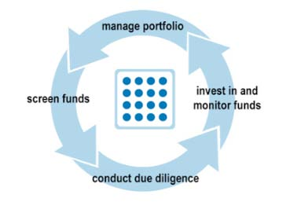
Figure 8
Manage Portfolio: Create pro forma portfolio from underlying funds, stress test and optimize portfolio, visualize impact of portfolio changes, reach long-term goals with retirement and wealth planner feature.
Screen Funds: Subscribe to investment databases, conduct searches, compare risk and return statistics, run peer group analysis.
Conduct Due Diligence: Store and update contact information for managers, references, prime brokers, administrators organize offering memoranda, questionnaires and other documents track emails, phone calls and meetings.
Invest in and Monitor Funds: Manage fund subscriptions and redemptions, track fund performance.

4.4 KEY TO MAXIMIZE RETURNS
"It is not timing the market, but time in the market that counts." Financial planning is a science. Creating and managing a portfolio is not a passive but an active exercise.

It's been widely known that long-term investments and proper asset allocation have been surer and successful methods of building wealth. Many an investor spends time in deciding the sector to invest in, the "multi-bagger" stock and also deciding the "time" to pick up the stock. When the markets move up, investor sentiment picks up, abuzz with their friends buying stocks, and investor's queue up to buy their "favorite multi-baggers". Typically, investors spend most of their time in deciding the stock to invest in and then trying to time the market to maximize returns.

4.5 TIPS TO HELP BUILD A DEBT PORTFOLIO
It is not often that investors come across a situation where both debt and equity offer attractive returns. However, in the recent months, that has been the case with banks resorting to a hike in deposit rates while the equity markets have staged a smart recovery. In line with this, fixed maturity plans (FMPs) are being launched while the corporate sector too has been tapping public money.
It is not a bad time to allocate some funds to debt provided the portfolio demands a debt allocation. Similarly, those looking at parking some money for short-term needs can use debt options. In fact, the next couple of months are likely to see increased action in the debt space and investors can expect a small hike in deposit rates.
There are plenty of options in the debt category and investors can choose the product according to their risk profile. Gone are the days when debt was considered a safe option. With interest rates being volatile, the debt products, particularly the ones like income funds and gilt funds, can be riskier in a rising interest rate regime.
Here are some tips to help investors build a debt portfolio:
- Short-term options: Traditional products like fixed deposits, corporate deposits or even cash management funds offered by mutual funds, can be good for the portfolio if the investment horizon is short. While cash management funds are good for very short periods, they are not a bad option in a rising interest rate scenario too. Fixed deposits on the other hand, can be looked at for a tenure of one year.
- Medium to long-term options: For some investors, debt allocation is a necessity as a matter of protection of capital. Hence, such investors chase debt products in line with their risk profile. Such investors can look at fixed maturity plans or monthly income plans besides fixed deposits.
For instance, options like monthly income plans work well when the investor looks at a period of 3-5 years. Besides the post office products, monthly income plans of mutual funds and fixed maturity plans can be good alternatives. In fact, a number of funds have already launched fixed maturity plans with different tenures and since they offer an indexation benefit when the tenure is more than one year, the product is also tax-efficient. The indexation benefit helps investors earn returns that are more realistic as they take into effect the inflation impact on the returns.
In the case of monthly income plans, there is a wider range of options which allow investors to allocate according to their risk profile. For instance, aggressive investors can go up to 20-25 per cent equity allocation, yet they are considered debt funds. They should not forget the risk, though minimal, because of the equity component. The risk is reduced because of the long tenure. Hence, they should not look at this product unless they can park money for a minimum of three years.
In comparison, fixed maturity plans are less risky as their equity allocation is much lower. Irrespective of the risk profile, every investor needs allocation towards debt as money needs to be spread across different assets. In fact, the need for debt allocation gets higher in line with the corpus.

4.6 SRI (SOCIALLY RESPONSIBLE INVESTING)
Socially responsible investing, also known as socially conscious or ethical investing, describes an investment strategy, which seeks to maximize both financial return and social good. In general, socially responsible investors favor corporate practices that promote environmental stewardship, consumer protection, human rights and diversity. Some (but not all) avoid businesses involved in alcohol, tobacco, gambling, weapons, the military, and/or abortion. The areas of concern recognized by the SRI industry can be summarized as environment, social justice, and corporate governance (ESG).

However, in a financial economics context, Socially Responsible Investing is a trade-off; due to its narrow investment scope it is typically not as well diversified as a portfolio without Socially Responsible requirements, and thus bears higher volatility without compensation in terms of higher returns.

4.7 MANAGE RISK WITH BALANCED PORTFOLIO
Risk management is a necessity for every investor. The challenge only gets bigger over a period of time as the portfolio grows in size. The concept of risk management was not an issue a few decades ago and in fact, many went after one asset as their choice and kept pumping money into it. For some, it was gold, and for a good chunk of investors, it was property. It is also the reason why you hear stories of many families struggling to manage their monthly needs despite holding acres of property. For many, these properties were not easy to liquidate due to legal disputes.
However, the scene has changed over the last decade largely because of the expansion in product range. What has also helped the investor is the growing awareness of risk associated with each product and their different investment cycles.
Interestingly, some products primarily do the job of risk management and hence, investors should allocate a portion of their corpus in their favor. Gold is one such example which is typically used as a tool to manage risk. Though the yellow metal has spikes in its performance at regular intervals, its primary job is risk management for a portfolio. As a result, it becomes a necessity for an investor to allocate around 510 percent in favor of gold.
Fixed return products like fixed deposits or pure debt instruments like short-term funds, fixed maturity plans (FMPs), and non-convertible debentures are some of the other options which reduce risk in a portfolio. Since all these products don't carry risk as they are not exposed to risky assets, their performance is generally on the expected lines.
While risk as a concept has different meaning for different investors, the general expectation is that the asset should not provide uncertain returns. In some cases, the investor is well aware that the returns are not guaranteed but he bets on it because of its ability to provide capital appreciation over the long term. Property is a classic example in this case. The asset does not offer guaranteed returns but every buyer takes comfort in the fact that the value of property goes up.

Some of these examples only reiterate the fact that the best way of managing risk is by choosing a basket of products for a portfolio. One can minimize risk through a combination of instruments or can even define a tenure for the portfolio . For instance, if a parent is investing for a child's education which could demand liquidity after 15 years, he need not look at fixed return products. Instead, he can create a long term portfolio and choose products that take care of the task of wealth creation.
Another option for wealth management is to divide the portfolio according to the risk profile and manage it accordingly. The high-risk portfolio would need attention at regular intervals and it also helps the investor to manage his time effectively. For instance, if an investor has chosen term insurance or fixed deposit for five years, he need not review them on a quarterly basis as there would not be any change in their performances. In the case of term plans, there is no bother of returns too as the product is not an investment linked one.

4.8 MID-CAP STOCKS (A Portfolio-booster, but tread with care)
With the BSE’s benchmark index, or Sensex, remaining flat for the last six months, many stock market investors, even first-time investors, are being advised that mid-cap and small-cap stocks could be a better bet.
According to experts, while the experienced investor can look at such stocks or mutual fund schemes, first timers should stay away. Depending on their risk profile and investment goals, the allocation (to such funds) should be 10-30% of their portfolio. First time investors who are yet to build a corpus can find themselves in trouble because these are high-beta stocks. In a falling market, mid-cap stocks or schemes will fall much faster and erode an investment’s value. Conversely mid and small-cap indices outperform the benchmark indices in a rising market. So, the mid-cap index could rise much sharper.

4.9 BUY AND HOLD OR QUIT AND FOLD
In this malaise-filled market, even buy-and-hold investors are starting to wonder whether they should give up on some of their beleaguered stocks.
Except in bad times, selling is a topic that long-term investors rarely consider. In fact, classic buy-and-hold investing calls for investors not to sell stocks now, but rather to add to their distressed holdings in a process called rebalancing. By booking some gains in, say, our bonds and commodity-related investments, and using the money to buy more beaten-down stocks, we will make sure that we sell high and buy low. If we don’t think we have the intestinal fortitude to buy more stocks now, we may need to reassess our risk tolerance, financial planners say.
How can we tell if it’s time to sell? In some instances, the decision is straightforward.
For example, if we buy a mutual fund precisely because we wanted something in our portfolio to perform well in difficult times — and our fund simply hasn’t kept pace with its peers over the last decade —we may want to reconsider. On the other hand, if we buy an investment as a core long-term holding for the next 20 years, there are a few questions to ask:
-  If we hold individual stocks, have the underlying reasons for buying them changed?
- “What makes a stock worth something is its projected earnings growth — which gets reflected ultimately in its price — and its dividend stream.”
- If our expectations about the profits or dividends of a company have changed drastically, it may be time to reassess.
- If we are a mutual fund investor, we have to ask our self how our funds have performed over the long term — and specifically against their peers.

4.10 MOVE YOUR MONEY, MANAGE IT BETTER
It's time to book a little profit and realign our portfolio according to our preferred debt-to-equity ratio. With stock markets rising more than 100 per cent in the last six months, it could be a good time for investors to take a relook at their portfolios.

Financial planners say that investors should ideally follow a defined equity-debt allocation and tweak investments accordingly once or twice a year.
It is important to note that if the equity investments have not been held for over a year, the investor will have pay 15 per cent as short-term capital gains tax. And that will mean a substantial reduction in returns. In this situation, one can wait for some more time before realigning the portfolio.
One could sit tight for some more time given that equities are having a good run and there is uncertainty on the debt front. Investors should choose depending on their risk appetite and financial goals.

4.11 SEEKING THE RIGHT BALANCE
If we look at the performance of equity-oriented balanced funds for the past one-year, the results are surprising. The returns vary between 25.76 per cent and 105.11 per cent. The disparity is due to higher equity allocations. Though they are called balanced funds, most invest 65-80 per cent of their corpus in equity. “This is as good as a diversified equity scheme.” This is perhaps one reason financial planners rarely use balanced funds (equity-oriented) while planning their clients’ investments. Most of them prefer separate equity and debt funds, though such an arrangement is not as tax efficient as a balanced fund (equity-oriented).
Conventionally, balanced funds were for investors who were not comfortable with equity-related volatility. However, a scheme that invests 65 per cent of its assets in stocks is classified as an equity scheme. Consequently, it is more tax efficient. “The variation in returns is due to higher exposure to stocks. Once allocation to equity increases, returns depend on fund managers.
Financial planners say due to this, they usually ask clients to create their own balanced funds. They invest one portion; say 60 per cent, in equity-diversified funds and the remaining in debt schemes. Such investments are easy to follow and evaluate against benchmarks.

Only investors who think that it is tedious to maintain this asset allocation can look for balanced funds that automatically take care of this task. The allocation that balanced funds maintain is more apt for the middle-aged (40-45 years). These funds also suit investors those who are graduating from minimal equity exposure to allocating more to stocks. “They will find equity diversified funds more volatile. Debt adds stability to balanced funds. In case of a correction, they fall less than pure equity funds. Diversified equity funds invest as much as 90-95% in shares. If we are going for balanced funds, long-term returns (over three-five years) are the first things we should look at. Also, we should check the asset allocation of the fund over the past one-year. Opt for a fund that has a stable asset allocation and keeps a minimum of 25% in debt. This shows that our fund manager does not go overboard when markets are bullish.

4.12 THE IMPORTANCE OF ASSET ALLOCATION
If we are not sure of our risk-taking capacity, consider investing in Templeton’s life-stage funds. These offerings are fund of fund schemes that invest in various mutual fund schemes having diverse investment objectives. The funds are deployed as per the pre-determined asset allocation that suits a particular type of an investor.
What is asset allocation?
Asset allocation means forming a strategy to decide how our wealth should be divided amongst various investment classes such as stocks, bonds, real estate and cash. This forms the core of any financial planning process, and is done at the start of the journey.
How do we decide on asset allocation?
Just like a doctor does a health check-up and prescribes a medicine, a financial planner prescribes a financial plan. Based on parameters such as our age, income, cash inflows and outflows, risk-taking capacity, the number of dependents, a planner profiles us to be a conservative, aggressive or a moderate investor. So a conservative investor could have 40% equity in his portfolio, with the balance spread across bonds, real estate and cash, while an aggressive investor could have even 80% equity in his portfolio.

How often should you rejig your portfolio?
The composition of assets in our portfolio would depend on market conditions. For instance, would the market value of our equity investment, double the share of equity in our portfolio, also rise accordingly? Once a financial plan is made, it should be monitored at least once a quarter and it could be released as infrequently as once a year. If during the course of the year, we want to make a lump sum investment of around Rs 1 lakh, just invest as per the asset allocation recommended to us by our investment advisor.

4.13 COMMON MISTAKES THAT CARELESS INVESTORS MAKE
Some of the common mistakes that careless investors make are:
- Not having a planned financial goal: If we do not know where we wish to reach, we’ll never know when we have. There are speed breakers on our journey, traffic lights and ‘dashing’ pedestrians. We may be a bit delayed in reaching, with a higher fuel consumption (investments may not deliver the desired returns), but we should never lose sight of the final destination. Taking more risks than that are necessary. Keep a close watch on our asset allocation.
- Targeting maximum returns on all investments at all times: How often have we changed lanes to the ‘faster-moving’ one in city, driving only to realize that our original ‘investment’ was better! It will be unwise to bet the savings that we need for a committed payment in the next three months in the equity market, irrespective of the euphoria prevailing. Equities are only meant for the long term.
- Aiming for maximum safety: For financial goals, that are some distance away (three years or plus), we need to benchmark investments suitably, rather than compare them on a weekly basis. We have to keep in mind our returns post-tax and the net of inflation.

- Relying on tips & neighbors’: When one of my colleague boasted of his conquests in trading, I was at first envious of him. Then I wanted to emulate him. As I grew wiser, I realized that he would only publicize his successes, and never his failures. Don’t we get tips of what to buy and when, but never when to sell? And that’s how dud stocks adorn our demat statements.
- Do-it-Yourself Mania: Ever wondered where India would have been if the world did not seek outsourcing? Handing over what we can’t do best to an expert is an accepted norm. But with the recent media explosion, we do feel that we have the ammunition to manage finances on our own.
The mantra is that three conditions need to co-exist: detailed understanding of finance; (full) time at our disposal; and ability to remove our emotions from our investment decisions (can sell poor selections at a loss) —only then can we do without a qualified financial advisor. Each one of us believes he is unique. Yet, we are checking if our list of investment mistakes matched that of others. And therein lies the next common mistake.

4.14 INVESTORS BET ON MULTINATIONAL COMPANIES FOR BIG RETURNS
Shares of multinational companies (MNCs) are the latest rage in the market, as investors scour for low-risk stocks with the potential to deliver good returns in a precariously poised market. Most shares in this segment have risen sharply, as investors are betting on greater focus by the foreign parent, given the strong growth prospects here. Many of these buyers are also seem to be betting that the parent companies may at some stage buy out the minority shareholders at a significant premium to the market price. But some brokers are quick to point out that the stock prices are already reflecting the expectations of a likely open offer.
Most of the stocks where the parent holds a large stake are attracting investors. Broadly, the buyers are bullish on the prospects of these companies. At the same time, there is a high probability that quite a few of these companies may delist as they do not require funds or the visibility that a listed firm enjoys.

A large number of MNCs are said to be shifting part of their operations to India due
to a combination of low cost and strong growth prospects. Till a few years back, Indian companies were perceived by investors as being aggressive players while MNCs were seen as conservative. But after the financial crisis, MNCs operating in India have emerged stronger in terms of valuations, reflecting expectations of higher growth from them.
According to experts, most of them are trading at attractive P/E levels with almost zero debt. Also, the focus on mid-cap stocks in the past few months has been attracting investors to this space

PRIMARY DATA

SELECTION OF THE SAMPLE
To get the information about the study, a survey has been conducted considering number of respondents. Respondents were selected by using random sampling technique. Samples would be chosen as various possible investments or funds under a portfolio. Data has been collected through questionnaire mainly considering various age groups, their risk perception, risk appetite, safety of principal, liquidity etc. Keeping this view in mind we followed a simple method of selecting respondents – following the method of “Simple Random Sampling”. The respondents were selected randomly. Due to the want of time and resources only 50 respondents were selected for the study.

Q 1. How do you look into Indian economy? TABLE 1:
Very Good | 10 | 20%
Good | 37 | 74%
Bad | 3 | 6%
Don’t Know | 0 | 0%

CHART 1:
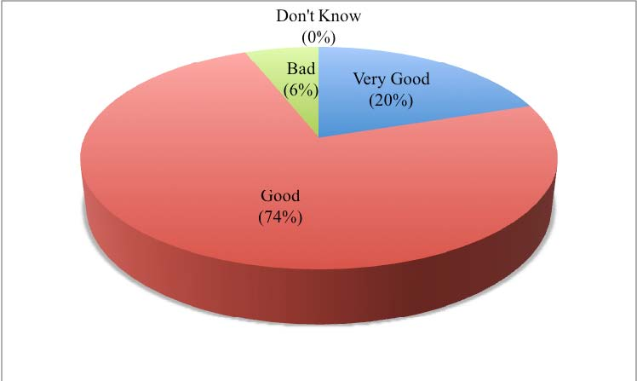
INTERPRETATION:
- 74% of the respondents have said Indian economy is good. This means that after the economic meltdown the Indian economy has been fairing well.
- 20% of the respondents have said Indian economy is very good. This means they feel that irresepective of the recession effects, the economy is doing good.
- 6% of the respondents feel Indian economy is bad. This means they still feel the economy has to grow for better means.

- Each and every respondent has a fair idea about Indian economy, therefore there were no respondents as such who said that they don’t know about Indian economy.
2. Being an investor, you must be aware of all investment options available today?
TABLE 2:
Yes | 32 | 64%
No | 17 | 34%
Didn’t Say | 1 | 2%

CHART 2:
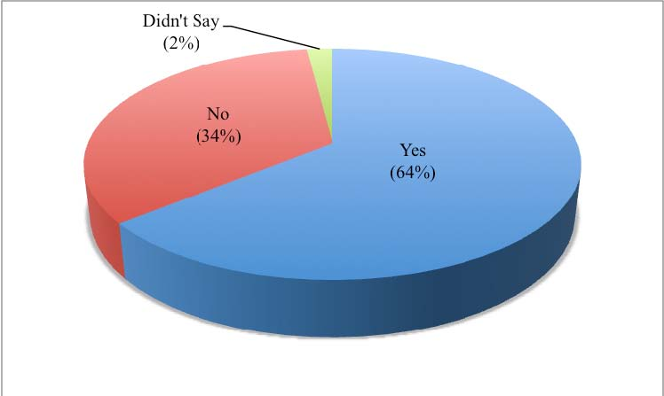
INTERPRETATION:
- 64% of the respondents are aware of all the investment options available. This means they have been tracking the market conditions and have a fair idea of what are the options available for investing wherein they can earn money.

- 34% of the respondents are not aware of the investment options available. This means they are least bothered to know about the options available for investing and rather try to play safe side by not taking too much of risk.
- 2% of the respondents didn’t say anything because they may not have any idea of what are the investment avenues and may be they take help of third party for their investments and remain ignorant.
3. If No, do you take help of an investment advisor?
TABLE 3:
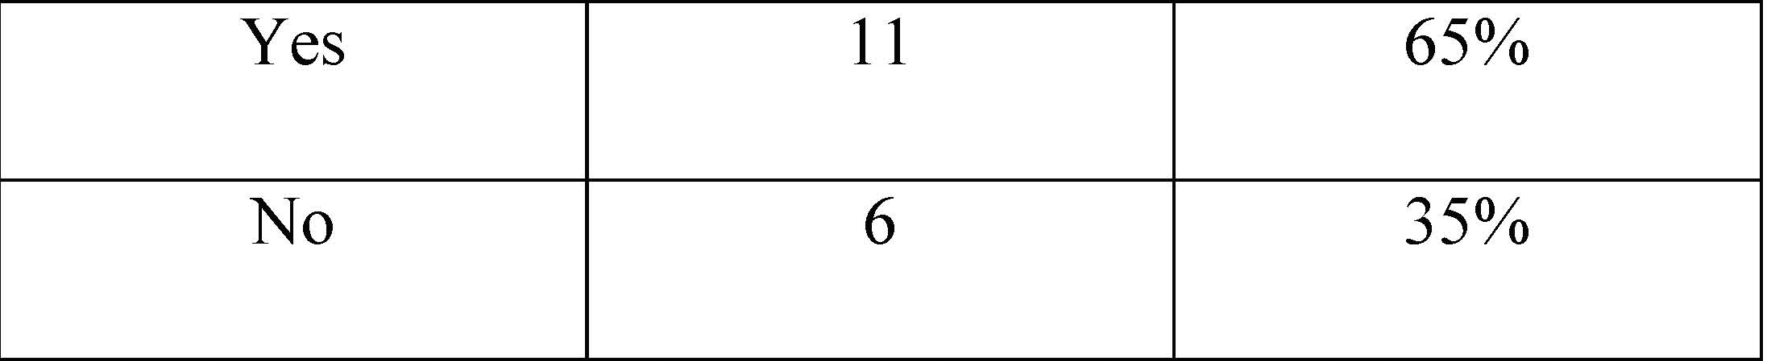
CHART 3:
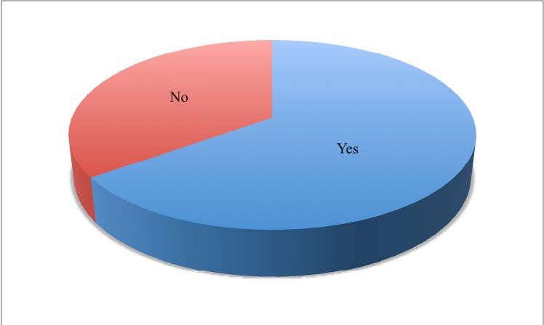
INTERPRETATION:
Out of total respondents, 34% (17) said they are not aware of all the investment options available and out of this,

- 65% of 17 respondents take the help of investment advisor because they are not aware of the present market conditions and its volatility and don’t want to take unnecessary risk by investing into various portfolio without understanding its consequences.
- 35% of 17 respondents don’t take help of investment advisor even if they are not aware of the investment avenues. This shows the ignorance of the investors and their lack of interest towards being educated regarding various investment options.
4. Is your investment objective for?
TABLE 4:
Retirement Planning | 14 | 28%
To meet major commitments | 13 | 26%
Wealth Creation | 19 | 38%
Others | 4 | 8%

CHART 4: INTERPRETATION:
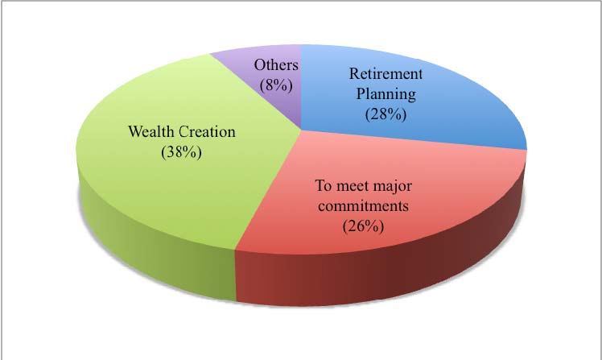

- 28% of the respondents have said their investment objective is for retirement planning. This means they are investing in order to secure their future after their retirement.
- 26% of the respondents have said their investment objective is to meet major commitments. Here major commitments means higher education for their dependents, marriage etc.
- 38% of the respondents have said their investment objective is for wealth creation. This means majority of the investors invest to create wealth. Their motto is to invest into various avenues and get maximum out of it.
- 8% of the respondents have said they have some other reasons for investment instead of creating wealth, to meet major commitments and retirement planning.
5. Prioritize your investment criteria? (Rate between 1 and 4)
TABLE 5:
RESPONDENTS | RETURN | RISK | LIQUIDITY | SAFETY OF PRINCIPAL
1 | 2 | 4 | 3 | 1
2 | 2 | 4 | 3 | 1
3 | 2 | 4 | 3 | 1
4 |  |  |  | 1
5 | 1 | 3 | 4 | 2
6 |  |  |  | 1
7 | 1 | 2 | 3 | 4
8 |  | 1
9 |  |  | 1
10 | 1 | 4 | 2 | 3
11 | 3 | 4 | 1 | 2
12 | 3 | 2 | 4 | 1
13 |  |  | 1
14 | 3 | 2 | 1 | 4
15 | 2 | 4 | 3 | 1
16 |  |  |  | 1
17 |  | 1
18 | 1

19 | 1
20 | 4 | 3 | 1 | 2
21 | 1
22 | 2 | 3 | 4 | 1
23 | 1 | 4 | 2 | 3
24 | 1 | 4 | 2 | 3
25 | 3 | 4 | 2 | 1
26 | 1 | 3 | 4 | 2
27 | 3 | 2 | 4 | 1
28 | 3 | 2 | 4 | 1
29 | 1 | 3 | 2 | 4
30 | 3 | 4 | 2 | 1
31 |  |  | 1
32 |  | 1
33 | 1
34 | 4 | 1 | 2 | 3
35 |  |  | 1
36 |  |  |  | 1
37 | 2 | 1 | 4 | 3
38 | 2 | 3 | 1 | 4
39 |  |  |  | 1
40 | 4 | 1 | 2 | 3
41 | 2 | 1 | 4 | 3
42 | 1 | 2 | 4 | 3
43 | 2 | 1 | 4 | 3
44 | 1
45 | 4 | 1 | 3 | 2
46 |  |  |  | 1
47 |  | 1
48 |  |  | 1
49 | 2 | 1 | 3 | 4
50 | 1 | 4 | 3 | 2

TOTAL(1st Priority) 14 11 9 16
INTERPRETATION:
- 28% of the respondents consider return as their frst priority out of the four investment criteria’s. These investors invest mostly for the sake of maximizing their returns.
- 22% of the respondents consider risk as their first priority out of the four investment criteria’s. These investors consider risk as the important factor and mostly invest into risky assets.
- 18% of the respondents consider liquidity as their first priority out of the four investment criteria’s. These investors need to keep the funds reasonably liquid. They want their investment as a measure with which something can be converted into cash.
- 32% of the respondents consider safety of principal as their first priority out of the four investment criteria’s. Most of the investors want their investment to be safe and don’t want to lose their money invested.
6. Do you review your portfolio?
TABLE 6:
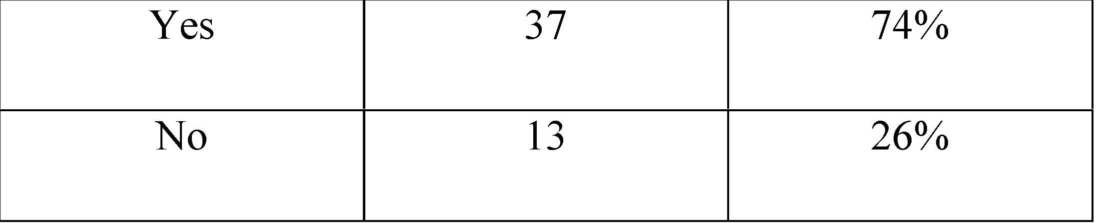
CHART 5:
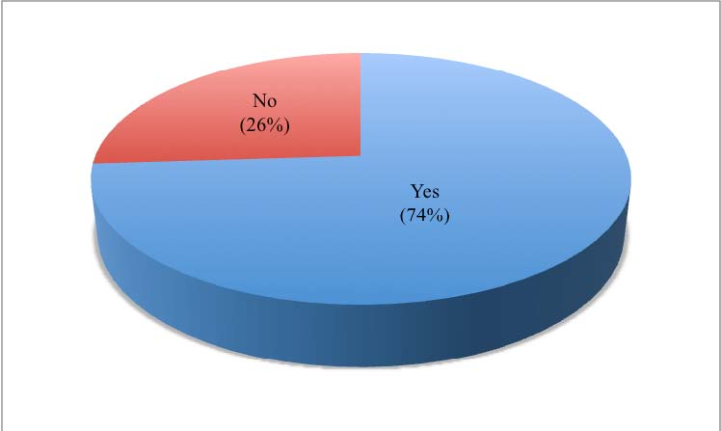
INTERPRETATION:
- 74% of the respondents review their portfolio. This means they are concerned about their investment and its consequences. They check frequently whether their portfolio is giving them the returns they are expecting otherwise they tend to review it. The frequency of review varies from investor to investor.

- 26% of the respondents do not review thir portfolio. This means once they create their portfolio they are not concerned anymore to check whether the portfolio is giving them the best returns and rather stick to it in the hope that the same portfolio would give them the best returns. It also shows they do not want to take risk of diversifying their investment and may be they do not have much idea of how market conditions are.
7. If yes, the reason for review and the frequency (How often you review)?
TABLE 7:
Weekly | 6 | 12%
Fortnightly | 1 | 2%
Quarterly | 7 | 14%
Monthly | 4 | 8%
Half-yearly | 4 | 8%
Yearly | 6 | 12%
Didn’t Say | 22 | 44%

CHART 6:
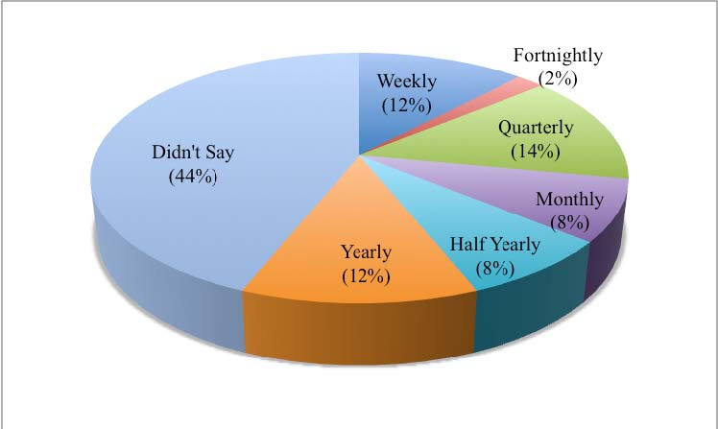
INTERPRETATION:
- 12% of the respondents review their portfolio weekly. This shows that these investors have concern for their investment and check every week whether their money is safe or else they need to reconstruct their portfolio.
- 14% of the respondents review their portfolio fortnightly. These investors review their investments once in two weeks. They keep themselves in track with the market conditions and its volatility. If their portfolio is faring well then they would continue with it .
- 8% of the repondents review their portfolio monthly. Every month these investors check whether their investment into various securities is giving them the expected returns or not.
- 14% of the respondents review their portfolio quarterly. These investors don’t review their portfolio frequently rather they review it in every three months. These investors may keep themselves in track with the market conditions and how well the securities are fairing in the market.
- 8% of the respondents review their portfolio for every 6 months. These investors continue with their investments for 6 months in the hope that those would give them the maximum returns. This is a risk which these investors are taking because it is not a long term investment and they are least bothered about their money in the market.

- 12% of the respondents review their portfolio yearly. These investors are rather very ignorant of how the market and economy is going on and may be they take help of the investment advisors. Due to this they least bother to check whether their money is safe and is getting them the required returns.
- 44% of the respondents don’t review their portfolio. This shows that how ignorant they are with respect to their money invested. They also don’t keep track of the market conditions and are not well educated about the investment avenues. Most of these investors fully depend upon their investment advisors and are least bothered of what is happening with their money. The only thing is they want their money invested to be safe and in the mean time get maximum returns out of it.
8. Which portfolio type you prefer? (Rate between 1 and 3)
TABLE 8:
RESPONDENTS | EQUITY | DEBT | BALANCED
1 | 1 | 2 | 3
2 | 1 | 3 | 2
3 | 3 | 2 | 1
4 |  |  | 1
5 | 1 | 3 | 2
6 | 1
7 | 2 | 1 | 3
8 | 2 | 3 | 1
9 | 1 | 2 | 3
10 | 2 | 3 | 1
11 | 3 | 2 | 1
12 | 3 | 1 | 2
13 |  |  | 1
14 | 3 | 2 | 1
15 | 1 | 2 | 3
16 | 1
17 |  |  | 1
18 |  |  | 1
19 |  |  | 1
20 | 3 | 2 | 1
21 | 1
22 | 1 | 3 | 2
23 | 1 | 3 | 2
24 | 1 | 3 | 2
25 | 2 | 3 | 1
26 | 3 | 2 | 1
27 | 1 | 2 | 3
28 | 2 | 3 | 1
29 | 1 | 3 | 2
30 | 2 | 3 | 1
31 | 1
32 |  |  | 1
33 | 3 | 1 | 2
34 |  | 1
35 | 2 | 1 | 3
36 | 3 | 2 | 1
37 |  | 1
38 | 2 | 3 | 1
39 |  |  | 1
40 | 2 | 1 | 3
41 | 1 | 3 | 2
42 | 3 | 1 | 2
43 | 2 | 1 | 3
44 |  |  | 1
45 |  |  | 1
46 |  | 1
47 |  |  | 1
48 | 1
49 | 1 | 3 | 2
50 | 3 | 2 | 1

INTERPRETATION:
- 34% of the respondents prefer equity as their portfolio type and their 1st priority. These investors put most of their money into equity rather than putting most of it in debt. They like to invest into risky assets and they are risk-takers.
- 20% of the respondents prefer debt as their portfolio type and their 1st priority. This shows that these investors put most of their money into bonds, debentures, fixed deposits etc. These investors tend to take less risk and are risk-aversers.
- 46% of the respondents prefer balanced as their portfolio type and their 1st priority. These investors don’t want to take much risk and are risk-neutral investors. They periodical rebalance their portfolio to ensure that the stock-bond mix is in line with the long-term ‘normal’ mix.
9. What proportion of your portfolio would you feel comfortable allocating to equities?
TABLE 9:
0-30% | 9 | 18%
30-60% | 33 | 66%
60-100% | 8 | 16%

CHART 7:
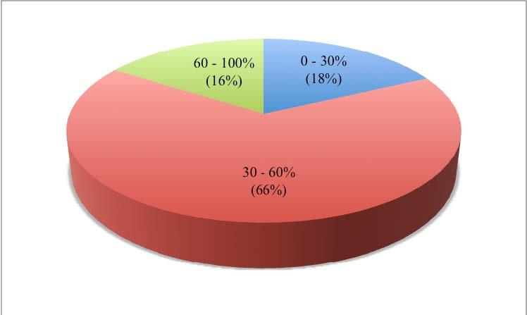
INTERPRETATION:
- 18% of the respondents allocate only 0 – 30% of their investment into equities. This means some of the investors do not want to take risk investing into equities rather they invest into debt or balanced (debt and equity).
- 66% of the respondents allocate 30 – 60% of their investments into equities. This means they are ready to take risk in the hope that they get maximum returns. These investors invest some of their money into equity like stock market and some into bonds, fixed deposits etc. thus diversifying their investments.
- 16% of the respondents allocate 60-100% of their investment into equities. This means there are very less investors who tend to take maximum risk of investing into equities. These investors are risk – takers and put almost all their money into stock market and hope they make profit out of that.

10. What is your investment time horizon? TABLE 10:
0 – 1 Year | 11 | 22%
1 – 3 Years | 27 | 54%
3 Years and above | 12 | 24%

CHART 8:
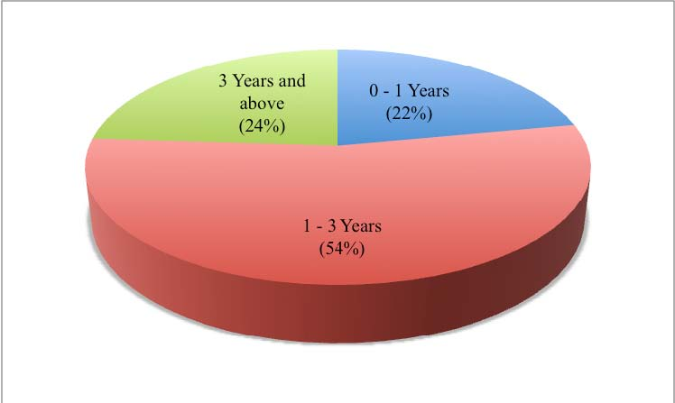
INTERPRETATION:
- 22% of the respondents invest with a shorter investment horizon i.e. 0 -1 year because they mostly tilt their portfolio in favour of bonds. May be they are more comfortable in investing in non – risky assets and do not want to take more risk in investing into stocks or risky assets.
- 54% of the respondents invest in a horizon of 1 – 3 years. This shows that the investors with a greater tolerance of risk tilt their portfolio in favour of stocks and with a lesser tolerance of risk tilt their portfolio in favour of bonds. Here if a risky investment performs poorly at the beginning of a short horizon, there  little these investors can do to compensate for loss of wealth but over a long horizon, these investors can postpone consumption, and work harder to achieve their financial goals.

- 24% of the respondents invest in a longer horizon of more than 3 years. This shows there are investors who tend to take much more risk and mostly into stocks. These investors think the risk of stocks diminsh as the investment period lengthens because they feel as the investment period lengthens, the average yearly return over the period is subject to lesser volatility because low returns in some years may be offset by high returns in other years and vice versa.
11. Please indicate your risk perception and risk taking abilities?
TABLE 11:
Risk Taker | 22 | 44%
Risk Averser | 10 | 20%
Risk Neutral | 18 | 36%

CHART 9: INTERPRETATION:
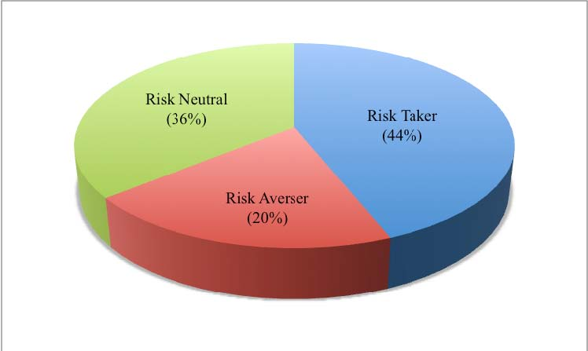

- 44% of the respondents are Risk-Takers. This means these investors have an appetite for risk and mostly they invest into risky assets. Their certainity equivalent to the expected monetary value is more than the expected value.
- 20% of the respondents are Risk-Aversers. These investors don’t want to take risk but expect higher returns from their investment. They don’t diversify their investments into risky assets but stick to the portfolio which gives constant returns. Here their certainity equivalent to the expected monetary value is less than the expected value.
- 36% of the respondents are Risk-Neutral. These investors are indifferent to risk. These investors play safe by diversifying their investments into both risky and non-risky assets. Their certainity equivalent to the expected monetary value is equal to the expected value.
12. When the portfolio return is on decline, how do you manage?
TABLE 12:
Reconstruct Portfolio | 13 | 26%
Rebalance Securities | 11 | 22%
Allow Existing Portfolio to continue | 15 | 30%
Withdraw | 11 | 22%

CHART 10:
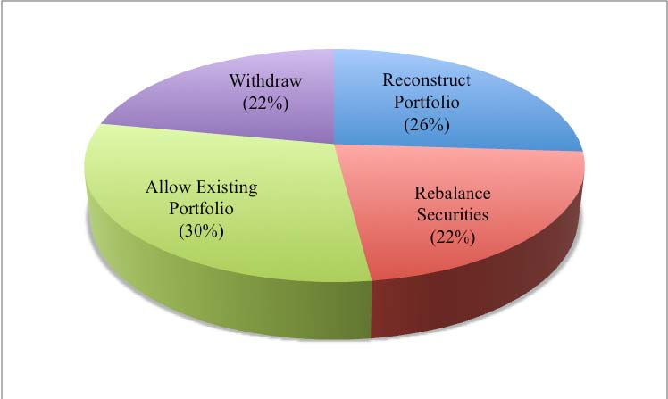
INTERPRETATION:
- 26% of the respondents have said that when their portfolio is on decline, they would reconstruct their portfolio by adding/deleting securities. They would rather look into diversifying their investments into different avenues which would rather provide higher returns.
- 22% of the respondents would rebalance their securities when their portfolio is on decline. These investors would continue with the same portfolio but would rebalance in the sense they would change the weightage of investment into different securities according to the market conditions and the returns they provide.
- 30% of the respondents would alow the existing portfolio to continue when their portfolio is on decline. These investors continue to invest in the same securities and also with the same weightage hoping the portfolio would maximize its return in the coming period. These investors mostly invest for a longer time horizon such that they could offset low returns in some years by high returns in other years and vice versa.
- 22% of the respondents would rather withdraw from the investment when the portfolio is on decline. These investors sense the market conditions and if their portfolio is not faring well and providing them their expected returns they   withdraw from their current investment and invest into other opportunities. They feel by investing into other opportunities they would maximize their returns which they are not getting in their existing portfolio.

13. Which would you prefer? TABLE 13:
Low Return with Low | 11 | 22%
Risk
Moderate Return with | 25 | 50%
Moderate Risk
High Return with High | 14 | 28%
Risk

CHART 11:
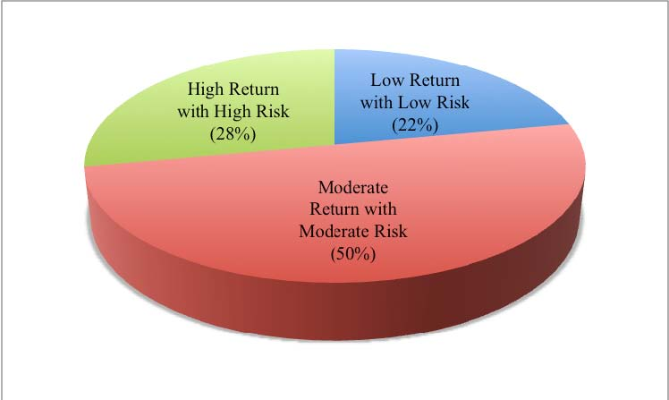
INTERPRETATION:

- 50% of the respondents prefer moderate return with moderate risk. These investors are risk neutral investors because they take moderate risk by investing into both equities and debt and other fixed income securities. By this their money invested is secured and get their principal amount back with moderate returns.
- 28% of the respondents prefer high return with high risk. These investors are risk takers as they largely invest into risky assets in the hope that they maximize their returns.

DATA ANALYSIS
As per the primary data collected through questionnaire and its interpretation we found that most of the investors want their money to be safe as their first priority. Thus these investors want be get their money back first then would go for maximizing their returns. Also from the interpretations, most of the investors prefer moderate return with moderate risk thus showing that they diversify their investments into balanced funds like equities as well as bonds and other fixed income securities. By this their investment remains safe and get moderate returns.
From the above analysis, we found out that “Most of the investors don’t prefer return as their investment criteria rather go for either risk or liquidity or safety of principal etc.”

CONCLUSIONS & RECOMMENDATIONS

From the above study we can conclude that,
- Most of them feel that Indian economy is doing good inspite of the economic hit recession.
- 64% of the respondents are aware of the investment options available today. This shows that remaining number of respondents are not aware and not well educated about the investment options.
- Out of 36% (18) who are not aware of investment options, 65% of them take help of investment advisor. This shows most of them are concern of their investment but remaining 35% out of 18 are ignorant of their investments and are least bothered to get educated.
- Most of the respondents (38%) investment objective is to create wealth. This shows most of them invest only for wealth creation by investing in for a longer period.
- 32% of the respondents prefer safety of principal as 1st priority as their investment criteria. This shows that the money invested by them has to be safe and their 1st motto is to get back the money invested then would go for maximizing their returns.
- 74% of the respondents review their portfolio. This shows that most of the investors are concern about their investments and like to keep track of the market conditions and its volatility.
- Most of the respondents review their portfolio quarterly but still there are 22% of these investors who don’t know to review their portfolio and are least bothered.
- Most of the respondents (46%) prefer balanced type of portfolio. These investors rather play safe by not taking too much of risk but at the same time they prefer to Risk-neutral. They like to diversify their investments into stock, bonds, fixed deposits etc.

- As these investors prefer balanced type, 66% of these investors invest 30-60% into equities. This clearly shows most of them are aware of the market conditions and want their money invested to be safe.
- Most of the respondents (54%) invest in a time horizon of 1-3 years. This shows that they tend to tilt their portfolio according to the market conditions and portfolio performance. If there is any loss in shorter time horizon, they would try to compensate their wealth loss in a longer horizon.
- 44% of the respondents are risk takers. This shows that most of them have the tendency to take risk and rather invest into risky assets. There are also 36% of the respondents who are risk neutral. So most of the investors lie in between taking too much of risk and taking some amount of risk.
- 30% of the respondents allow their existing portfolio to continue. These investors want to invest into the same portfolio for a longer period so as to maximize their returns and also to offset for any loss in shorter period. By this their money invested is safe and almost get their expected returns.
- 50% of the respondents prefer moderate return with moderate risk. This shows that half of the respondents don’t take much of a risk by investing into risky assets but rather diversify their investments into both risky as well as non-risky assets.
So far in India, most of the middle class earners have been risk-averse and therefore park most of their savings in Fixed Deposits and Other Savings Accounts, though the yield from such investment avenues is very low. However, the recent trend has been such that more people have been attracted towards investment in Mutual Funds and Equities. It is in this light that Portfolio Management Companies have been gaining prominence in India. The trend is only set to go upwards in the years to come, as the Indian middle class becomes more risk friendly.

We expect that following these recommendations could result in higher abnormal return for the investors:
- The investors should have a clear understanding of their investment objectives, tax status and risk tolerances. Only by this the portfolio managers can offer suitable advice or construct appropriate portfolios.
- Investment must be with reputed organization. Before investment we should be aware of the standards of the company where we want to invest. Standards of the company means, balance sheet, size, management capability etc. of the company must be excellent.
- The investment should be carefully done for the previous performance, present market status and future risk properly assessed for better results.
- Equity should be invested in such a manner that assured return must be guaranteed by regularly watching the market volatility to avoid higher risk.
- Where compatible with investor’s objectives we recommend investing in equities on a long-term basis. The reason is that equities tend to offer better returns than alternative investment classes over periods of ten years or more. Although equity prices may be volatile on a day-to-day basis the effects of this are reduced over time if prices are on a rising trend. The effects of volatility are also reduced by holding a portfolio of equities with an appropriate spread of exposures to different sectors and/or countries.
- Not all clients can accept the risk of being fully invested in equities and others may require higher levels of income than can be prudently achieved from a pure equity portfolio. In these cases we will recommend investors setting aside a part of the portfolio for investment in fixed income stocks (bonds).
- While managing the investment portfolio, it is important to remember that the riskier strategic investments should always be balanced with more conservative investments. The investment mix should be constantly monitored to assess which investments are on track, and which are the ones that need help and which are the ones that need to be shut down.

- A huge market downturn: A simpler way to deal is to re-balance the portfolio to whatever the target equity weight is, trimming stocks and adding to fixed income or money market. This is a good discipline to get into on a regular basis and helps buffer the portfolio against the inevitable volatility we see in equity markets.
- Most people need a balance of stocks and bonds in their portfolio, so the question is how much of each. If they are worried about inflation, we would look at using some of the RRB's (Real Return Bonds), high quality corporate bonds to increase the yield and reduce susceptibility to any increases in interest rates and keep their term relatively short. Overall, we believe the risk: reward relationship favours stocks over bonds at this point, so we are overweight stocks and underweight bonds.

GLOSSARY

- Active Management: A dynamic investment policy that requires periodic action by the portfolio manager.
- Beta: A measure of the systematic risk of an asset. The average beta is 1; securities with a beta more than this are more risky than average, and vice versa.
- Buy and hold: A passive, naive investment strategy in which someone buys a security and maintains the security position without revision.
- Capital appreciation: One of the four principal portfolio objectives, in which the fund manager seeks to increase the principal value of the fund rather than to generate income.
- Capital asset pricing model (CAPM): A theoretical model measuring the expected return of an asset in terms of its beta and the expected return on a broad market index.
- Capital market line: A line drawn in expected return / standard deviation space from the risk – free rate to the market portfolio.
- Closed-end fund: A portfolio of securities with a finite number of shares that are traded publicity, often on a stock exchange.
- Constant beta portfolio: An investment portfolio in which the manager seeks to keep the portfolio’s systematic risk (as measured by beta) constant.
- Constant proportion portfolio: An investment portfolio in which the manager seeks to keep the proportion of investment funds placed into each security position approximately constant.
- Economic risk: The chance of loss due to adverse factors regarding quality, liquidity, demand, price, management, or regulation.
- Efficient frontier: The collection of dominant portfolios for given levels of risk or return.
- Effective portfolio: A collection of securities whose risk and expected return combination plots on the efficient frontier.

- Financial risk: The variation of returns that is a function of the extent to which borrowed funds are used in the generation of the returns.
- Fund manager: The person responsible for investment decisions in a portfolio or mutual fund.
- Fund objective: The stated intent of an investment fund, especially a mutual fund. Some objectives are income, capital appreciation, and tax-free income.
- Growth: One of the four principal investment objectives, in which an investor seeks an increase in the principal value of a fund at the expense of current income.
- Growth of income: One of the four principal investment objectives, in which the level of income generated by a portfolio is expected to grow each year.
- Inconsistent objectives: An impossible combination of primary and secondary portfolio objectives. A person cannot, for instance, couple capital appreciation with stability of principal.
- ➢ Investment horizon: The period of time a particular investment is expected to be held.
- Jensen measure: A seldom-used measure of performance evaluation. A Jensen measure greater than 0 indicates that a security has shown an upward drift in its price that is unexplainable by its level of systematic risk.
- Liquidity: The extent to which something can be quickly converted into crash at approximately its market value.
- Market risk: The chance of loss due to adverse movements in the level of the stock market.
- Markowitz diversification: Diversification designed to exploit the covariance’s of the portfolio components.
- Mutual fund: A collection of securities with a variable number of shares; also called an open end fund. Mutual fund shares are not publicly traded on an exchange. When an investor wants to buy shares in a mutual fund, new shares are created. When an investor wants to sell shares, they are redeemed. And they disappear.

- Passive management: A management strategy in which the investment manager does not takes an active role in revising the portfolio components.
- Portfolio investment: Foreign investment via the securities markets; also known as financial investment.
- Primary objective: The principal goal of a portfolio; either capital appreciation, growth of income, income, or stability of principal.
- Rebalancing: The practice of adjusting the proportions held in various securities in accordance with a predetermined portfolio policy such as constant beta or equal weighting.
- Risk: Change of loss.
- Risk aversion: The general economic characteristic of investors whereby everything else being equal, investors prefer less risk.
- Security market line (SML): A plot of the expected returns of securities against their betas.
- Stability of principal: An investment objective in which an investor indicates he or she wants to chance of any deterioration in the original principal value. This is the most conservative of the four traditional investment objectives.
- Systematic risk: The variance of the securities returns that stems from overall market movements and is measured by beta.
- Total risk: The sum of systematic and unsystematic risk. Variance of return (or standard deviance) is used to measure total risk.
- Unsystematic risk: Diversifiable risk is that is unique to a particular company.

Bibliography

Books

- Stock Investing For Dummies by Paul J. Mladjenovic
- The Intelligent Investor: The Definitive Book on Value Investing. by Benjamin Graham, Jason Zweig and Warren E. Buffett
- Managing Investment Portfolios: A Dynamic Process (CFA Institute Investment Series) by John L.
- Investment Analysis and Portfolio Management (with Thomson ONE - Business School Edition) by Frank K.
- Indian Stock Market by Bishnupriya Mishra and Sathya Swaroop Debasish

Web Site

- www.moneycontrol.com
- www.nseindia.com
- www.bseindia.com
- www.sebi.gov.in
- http://en.wikipedia.org/wiki/Securities_and_Exchange_Board_of_India

