Project Title

An exploratory study on
“Risk Management in Banking Sector”

Submitted By

Mr. XXXXX XXXXXXX

MBA in Banking (Finance)
XXXXX University

CHAPTER I

INTRODUCTION
  - THEME OF THE STUDY

Risk management underscores the fact that the survival of an organization depends heavily on its capabilities to anticipate and prepare for the change rather than just waiting for the change and react to it. The objective of risk management is not to prohibit or prevent risk taking activity, but to ensure that the risks are consciously taken with full knowledge, purpose and clear understanding so that it can be measured and mitigated. It also prevents an institution from suffering unacceptable loss causing an institution to suffer or materially damage its competitive position. Functions of risk management should actually be bank specific dictated by the size and quality of balance sheet, complexity of functions, technical/ professional manpower and the status of MIS in place in that bank.

1.2 INTRODUCTION

Risk: the meaning of ‘Risk’ as per Webster’s comprehensive dictionary is “a chance of encountering harm or loss, hazard, danger” or “to expose to a chance of injury or loss”. Thus, something that has potential to cause harm or loss to one or more planned objectives is called Risk.
The word risk is derived from an Italian word “Risicare” which means “To Dare”. It is an expression of danger of an adverse deviation in the actual result from any expected result.
Banks for International Settlement (BIS) has defined it as- “Risk is the threat that an event or action will adversely affect an organization’s ability to achieve its objectives and successfully execute its strategies.”
Risk Management: Risk Management is a planned method of dealing with the potential loss or damage. It is an ongoing process of risk appraisal through various methods and tools which continuously

- Assess what could go wrong
- Determine which risks are important to deal with
- Implement strategies to deal with those risks
1.3 STUDY PROBLEM

Basel II norms came as an attempt to reduce the gap in point of views between conflict practices. Therefore, the implementation of those resolutions emerged by the banks. Regarding this issue the survey has been made.

Study problem can be stated as follows:
To what extent banks have implemented Basel II norms related to enhancing internal control in the banks?

1.4 OBJECTIVES

- Covering different aspects of risk assessment
- Identifying keys for effective risk management
- To understand the challenges and impact of Implementing Basel II
- To analyze the current progress of Basel II in Hubli.

1.5 METHODOLOGY

- Literature Review
- Data collection
  - Primary information: Personal interview/ Questionnaire
  - Secondary information: Through internet, Manuals, Journals, Audit/Annual reports
- The Benefits and limitation of Basel II
- The Challenges of Implementing Basel II
- Impact of Basel II
- Research method
- Findings and suggestions
- Conclusion

CHAPTER II
LITRETURE REVIEW

2.1 INTRODUCTION

Basel I Accord: The Basel Committee on Banking Supervision, which came into existence in 1974, volunteered to develop a framework for sound banking practices internationally. In 1988 the full set of recommendations was documented and given to the Central banks of the countries for implementation to suit their national systems. This is called the Basel Capital Accord or Basel I Accord. It provided level playing field by stipulating the amount of capital that needs to be maintained by internationally active banks.

Basel II Accord: Banking has changed dramatically since the Basel I document of 1988. Advances in risk management and the increasing complexity of financial activities / instruments (like options, hybrid securities etc.) prompted international supervisors to review the appropriateness of regulatory capital standards under Basel I. To meet this requirement, the Basel I accord was amended and refined, which came out as the Basel II accord.

The new proposal is based on three mutually reinforcing pillars that allow banks and supervisors to evaluate properly the various risks that banks have to face and realign regulatory capital more closely with underlying risks. Each of these three pillars has risk mitigation as its central board. The new risk sensitive approach seeks to strengthen the safety and soundness of the industry by focusing on:

● Risk based capital (Pillar 1)
● Risk based supervision (Pillar 2)
● Risk disclosure to enforce market discipline (Pillar 3)

2.2 BASEL II FRAMEWORK

The new proposal is based on three mutually reinforcing pillars that allow banks and supervisors to evaluate properly the various risks that banks face and realign regulatory capital more closely with underlying risks.

Basel II
Framework

Pillar I Pillar II Pillar III
Minimum Capital Supervisory Market
Requirements Review Process Discipline

2.2.1 THE FIRST PILLAR – MINIMUM CAPITAL REQUIREMENTS

The first pillar sets out minimum capital requirement for the bank. The new framework maintains minimum capital requirement of 8% of risk assets.
Basel II focuses on improvement in measurement of risks. The revised credit risk measurement methods are more elaborate than the current accord. It proposes for the first time, a measure for operational risk, while the market risk measure remains unchanged.

2.2.2 THE SECOND PILLAR - SUPERVISORY REVIEW PROCESS

Supervisory review process has been introduced to ensure not only that bank have adequate capital to support all the risks, but also to encourage them to develop and use better risk management techniques in monitoring and managing their risks. The process has four key principles-
a) Banks should have a process for assessing their overall capital adequacy in relation to their risk profile and a strategy for monitoring their capital levels.

b) Supervisors should review and evaluate bank’s internal capital adequacy assessment and strategies, as well as their ability to monitor and ensure their compliance with regulatory capital ratios.

c) Supervisors should expect banks to operate above the minimum regulatory capital ratios and should have the ability to require banks to hold capital in excess of the minimum.

d) Supervisors should seek to intervene at an early stage to prevent capital from decreasing below minimum level and should require rapid remedial action if capital is not mentioned or restored.

2.2.3 THE THIRD PILLAR – MARKET DISCIPLINE

Market discipline imposes strong incentives to banks to conduct their business in a safe, sound and effective manner. It is proposed to be effected through a series of disclosure requirements on capital, risk exposure etc. so that market participants can assess a bank’s capital adequacy. These disclosures should be made at least semi-annually and more frequently if appropriate. Qualitative disclosures such as risk management objectives and policies, definitions etc. may be published annually.

2.3 TYPES OF RISKS

When we use the term “Risk”, we all mean financial risk or unexpected financial loss. If we consider risk in terms of probability or occur frequently, we measure risk on a scale, with certainty of occurrence at one end and certainty of non-occurrence at the other end. Risk is the greatest phenomena where the probability of occurrence or non-occurrence is equal. As per the Reserve Bank of India guidelines issued in Oct. 1999, there are three major types of risks encountered by the banks and these are Credit Risk, Market Risk & Operational Risk. Further after eliciting views of banks on the draft guidelines on Credit Risk Management and market risk management, the RBI has issued the final guidelines and advised some of the large PSU banks to implement so as to gauge the impact. Risk is the potentiality that both the expected and unexpected events may have an adverse impact on the bank’s capital or its earnings. The expected loss is to be borne by the borrower and hence is taken care of by adequately pricing the products through risk premium and reserves created out of the earnings. It is the amount expected to be lost due to changes in credit quality resulting in default. Where as, the unexpected loss on account of the individual exposure and the whole portfolio is entirely borne by the bank itself and hence care should be taken. Thus, the expected losses are covered by reserves/provisions and the unexpected losses require capital allocation.

2.3.1 CREDIT RISK

In the context of Basel II, the risk that the obligor (borrower or counterparty) in respect of a particular asset will default in full or in part on the obligation to the bank in relation to the asset is termed as Credit Risk.
Credit Risk is defined as-“The risk of loss arising from outright default due to inability or unwillingness of the customer or counter party to meet commitments in relation to lending, trading, hedging, settlement and other financial transaction of the customer or counter party to meet commitments”.
Credit Risk is also defined, “as the potential that a borrower or counter party will fail to meets its obligations in accordance in agreed terms”.

2.3.2 MARKET RISK

It is defined as “the possibility of loss caused by changes in the market variables such as interest rate, foreign exchange rate, equity price and commodity price”. It is the risk of losses in, various balance sheet positions arising from movements in market prices.
RBI has defined market risk as the possibility of loss to a bank caused by changes in the market rates/ prices. RBI Guidance Note focus on the management of liquidity Risk and Market Risk, further categorized into interest rate risk, foreign exchange risk, commodity price risk and equity price risk.
Market risk includes the risk of the degree of volatility of market prices of bonds, securities, equities, commodities, foreign exchange rate etc., which will change daily profit and loss over time; it’s the risk of unexpected changes in prices or rates. It also addresses the issues of Banks ability to meets its obligation as and when due, in other words, liquidity risk.

2.3.3 OPERATIONAL RISK

Operational risk is the risk associated with the operations of an organization. It is defined as “risk of loss resulting from inadequate or failed internal process, people and systems or from external events.”
It includes legal risk. It excludes strategic and reputational risks, as the same are not quantifiable.
Operational risk includes the risk of loss arising from fraud, system failures, trading error and many other internal organizational risks as well as risk due to external events such as fire, flood etc. the losses due to operation risk can be direct as well as indirect. Direct loss means the financial losses resulting directly from an incident or an event. E.g. forgery, fraud etc. indirect loss means the loss incurred due to the impact of an incident.

2.3.4 REGULATORY RISK

The owned funds alone are managed by an entity, it is natural that very few regulators operate and supervise them. However, as banks accept deposit from public obviously better governance is expected from them. This entails multiplicity of regulatory controls. Many Banks, having already gone for public issue, have a greater responsibility and accountability in this regard. As banks deal with public funds and money, they are subject to various regulations. The various regulators include Reserve Bank of India (RBI), Securities Exchange Board of India (SEBI), Department of Company Affairs (DCA), etc. More over, banks should ensure compliance of the applicable provisions of The Banking Regulation Act, The Companies Act, etc. Thus all the banks run the risk of multiple regulatory-risks which inhibits free growth of business as focus on compliance of too many regulations leave little energy scope and time for developing new business. Banks should learn the art of playing their business activities within the regulatory controls.

2.3.5 ENVIRONMENTAL RISK

As the years roll the technological advancement takes place, expectation of the customers change and enlarges. With the economic liberalization and globalization, more national and international players are operating the financial markets, particularly in the banking field. This provides the platform for environmental change and exposure of the bank to the environmental risk. Thus, unless the banks improve their delivery channels, reach customers, innovate their products that are service oriented; they are exposed to the environmental risk.
2.4 BASEL’S NEW CAPITAL ACCORD
Bankers’ for International Settlement (BIS) meet at Basel situated at Switzerland to address the common issues concerning bankers all over the world. The Basel Committee on Banking Supervision (BCBS) is a committee of banking supervisory authorities of G-10 countries and has been developing standards and establishment of a framework for bank supervision towards strengthening financial stability through out the world. In consultation with the supervisory authorities of a few non-G-10 countries including India, core principles for effective banking supervision in the form of minimum requirements to strengthen current supervisory regime, were mooted. The 1988 Capital Accord essentially provided only one option for measuring the appropriate capital in relation to the risk weighted assets of the financial institution. It focused on the total amount of bank capital so as to reduce the risk of bank solvency at the potential cost of bank’s failure for the depositors. As an improvement on the above, the New Capital Accord was published in 2001 by Basel Committee of Banking Supervision. It provides spectrum of approaches for the measurement of credit, market and operational risks to determine the capital required. The spread and nature of the ownership structure is important as it impinges on the propensity to induct additional capital. While getting support from a large body of shareholders is a difficult proposition when the bank’s performance is adverse, a smaller shareholder base constrains the ability of the bank to garner funds. Tier I capital is not owed to anyone and is available to cover possible unexpected losses. It has no maturity or repayment requirement, and is expected to remain a permanent component of the core capital of the counter party. While Basel standards currently require banks to have a capital adequacy ratio of 8% with Tier I not less than 4%, RBI has mandated the banks to maintain CAR of 9%. The maintenance of capital adequacy ratio is like aiming at a moving target as the composition of risk-weighted assets gets changed every now and then on account of fluctuations in the risk profile of a bank. Tier I capital is known as the core capital providing permanent and readily available support to the bank to meet the unexpected losses. In the recent past, owners of PSU banks, the government provided adequate capital to weaker banks to ease the burden. In doing so, the government was not acting as a prudent investor as return on such capital was never a consideration. Further, capital infusion did not result in any cash flow to the receiver, as all the capital was required to be reinvested in government securities yielding low returns. Receipt of capital was just a book entry with the only advantage of income from the securities.
2.5 CAPITAL ADEQUACY

Subsequent to nationalization of banks, capitalization in banks was not given due importance as it was felt necessary for the reason that the ownership of the banks rested with the government, creating the required confidence in the mind of the public. Combined forces of globalization and liberalization compelled the public sector banks, hitherto shielded from the vagaries of market forces, come by the condition of terms market realities, where certain minimum capital adequacy has to be maintained in the face of stiff norms in respect of income recognition, asset classification and provisioning. It is clear that multi pronged approach would be required to meet the challenges of maintaining capital at adequate levels in the face of mounting risks in the banking sector. In banks, asset creation is an event happening subsequent to the capital formation and deposit mobilization.

2.6 RISK AGGREGATION & CAPITAL ALLOCATION
Capital Adequacy in relation to economic risk is a necessary condition for the long-term soundness of banks. Aggregate risk exposure is estimated through Risk Adjusted Return on Capital (RAROC) and Earnings at Risk (EaR) method. Former is used by bank with international presence and the RAROC process estimates the cost of Economic Capital & expected losses that may prevail in the worst-case scenario and then equates the capital cushion to be provided for the potential loss. RAROC is the first step towards examining the institution’s entire balance sheet on a mark to market basis, if only to understand the risk return trade off that have been made. As banks carry on the business on a wide area network basis, it is critical that they are able to continuously monitor the exposures across the entire organization and aggregate the risks so that an integrated view can be taken. The Economic Capital is the amount of the capital (besides the Regulatory Capital) that the firm has to put at risk so as to cover the potential loss under the extreme market conditions. In other words, it is the difference in mark-to-market value of assets over liabilities that the bank should aim at or target. As against this, the regulatory capital is the actual Capital Funds held by the bank against the Risk Weighted Assets. After measuring the economic capital for the bank as a whole, bank’s actual capital has to be allocated to individual business units on the basis of various types of risks. This process can be continued till capital is allocated at transaction/customer level.
2.7 RISK BASED SUPERVISION (RBS)

The Reserve Bank of India presently has its supervisory mechanism by way of on-site inspection and off-site monitoring on the basis of the audited balance sheet of a bank. In order to enhance the supervisory mechanism, the RBI has decided to put in place, a system of Risk Based Supervision. Under risk based supervision, supervisors are expected to concentrate their efforts on ensuring that financial institutions use the process necessarily to identify measure and control risk exposure. The RBS is expected to focus supervisory attention in accordance with the risk profile of the bank. The RBI has already structured the risk profile templates to enable the bank to make a self-assessment of their risk profile. It is designed to ensure continuous monitoring and evaluation of risk profile of the institution through risk matrix. This may optimize the utilization of the supervisory resources of the RBI so as to minimize the impact of a crises situation in the financial system. The transaction based audit and supervision is getting shifted to risk focused audit. Risk based supervision approach is an attempt to overcome the deficiencies in the traditional point-in-time, transaction- validation and value based supervisory system. It is forward looking enabling the supervisors to differentiate between banks to focus attention on those having high-risk profile. The implementation of risk based auditing would imply that greater emphasis is placed on the internal auditor’s role for mitigating risks. By focusing on effective risk management, the internal auditor would not only offer remedial measures for current trouble-prone areas, but also anticipate problems to play an active role in protecting the bank from risk hazards.

2.8 RISK MANAGEMENT:
KEYS FOR EFFECTIVE RISK MANAGEMENT:

- To direct risk behaviour & influence the shape of a firm’s risk profile, management should use all available options. Using financial incentives and penalties to influence risk taking behaviour is effective management tool.

- Sharing of information by keeping confidentiality intact is also helpful to find out different ways for controlling the risk as valuable inputs may be received through this sharing. Even information on creditworthiness of counterparties that are known to take substantial risk can also help.

- Diversification is extremely important. As it lowers the variance in investor portfolios, improves corporate ability to raise debt, reduces employment risks, & heightens operating efficiency.

- Governance should never be ignored. Careful structuring of the alliance in advance of the deal and continual adjustment thereafter help to build a constructive relationship.

- One should not trust while in business. Personal chemistry is good but is no substitute for monitoring mechanism, co-operation incentives, & organizational alignment.

- Without support system within the organization itself, external alliances are doomed to fail.

2.8.1 MARKET RISK MANAGEMENT:

We may believe that there are limited tools available to mitigate this risk, but this is not so. Future, option, derivatives trading and its many sub types are some of the tools which help to investors to protect the investment or minimize there exposure toward market risk. In case of derivatives as in broader sense derivatives are considered to be used to hedge against market risk, but they can be used to mitigate various other types of risks, like credit risk, operational risk.
The importance of managing market risk has now been well understood by financial institutions and corporate across the world. Market risk has made the global financial conditions uncertain and unsettled and still recovery of problem is not visible in the near time.

2.8.2 CREDIT RISK MANAGEMENT

Tools of Credit Risk Management: The instruments and tools, through which credit risk is managed are: Exposure Ceilings, Review/Renewal, Risk Rating Model, Risk based scientific pricing, Portfolio Management, Loan Review Mechanism

2.8.3 OPERATIONAL RISK MANAGEMENT:

This risk can be reduced to great extent by effectively controlling organization as a whole by taking certain steps, like assuring that designed processes is carried out carefully & with the help of experts, and are followed in desired way.

2.9 COMPUTATION OF CAPITAL REQUIREMENT

2.9.1 CREDIT RISK APPROACHES
Credit Risk

Standardized approach Advanced Approach

Foundation IRB Advanced IRB
Standardized approach: the Basel committee as well as RBI provides a simple methodology for risk assessment and calculating capital requirements for credit risk called Standardized approach. This approach is divided into the following broad topics for simpler and easier understanding
1. Assignment of Risk Weights: all the exposures are first classified into various customer types defined by Basel committee or RBI. Thereafter, assignment of standard risk weights is done, either on the basis of customer type or on basis of the asset quality as determined by rating of the asset, for calculating risk weighted assets.

2. External Credit Assessments: the regulator or RBI recognizes certain risk rating agencies and external credit assessment institutions (ECAIs) and rating assigned by these ECAIs, to the borrowers may be taken as a basis for assigning risk weights to the borrowers. Better rating means better quality of assets and lesser risk weights and hence lesser requirement of capital allocation.

3. Credit Risk Mitigation: Basel recognized Collaterals and Basel recognized Guarantees are two securities that banks obtain for loans / advances to cover credit risk, which are termed as “Credit Risk Mitigants”

Advanced Approach: Basel II framework also provides for advanced approaches to calculate capital requirement for credit risk. These approaches rely heavily on a banks internal assessment of its borrowers and exposures. These advanced approached are based on the internal ratings of the bank and are popularly known as Internal Rating Based (IRB) approaches. Under Advanced Approaches, the banks will have 2 options as under
a) Foundation Internal Rating Based (FIRB) Approaches.
b) Advanced Internal Rating Based (AIRB) Approaches.

The differences between foundation IRB and advanced IRB have been captured in the following table: Table 2.9.1.1: The differences between foundation IRB and advanced IRB

Data Input | Foundation IRB | Advanced IRB
Probability of Default | Provided by bank based on own estimates | Provided by bank based on own estimates
Loss Given Default | Supervisory values set by the Committee | Provided by bank based on own estimates
Exposure at Default | Supervisory values set by the Committee | Provided by bank based on own estimates
Effective Maturity | Supervisory values set by the Committee | Provided by bank based on own estimates Or At the national discretion, provided by bank based on own estimates

2.9.2 MARKET RISK APPROACHES

Market Risk

Standardized Internal Model
Approach Based approach

Maturity Duration
Based Based

RBI has issued detailed guidelines for computation of capital charge on Market Risk in June 2004. The guidelines seek to address the issues involved in computing capital charge for interest rate related instruments in the trading book, equities in the trading book and foreign exchange risk (including gold and precious metals) in both trading and banking book. Trading book will include:
- Securities included under the Held for trading category
- Securities included under the Available for Sale category
- Open gold position limits
- Open foreign exchange position limits
- Trading position in derivatives and derivatives entered into for hedging trading book exposures.

2.9.3 OPERATIONAL RISK APPROACHES

Operational
Risk

Basic Indicator Standardized Advanced
Approach Approach Measurement
Approach

Basic Indicator Approach: Under the basic indicator approach, Banks are required to hold capital for operational risk equal to the average over the previous three years of a fixed percentage (15% - denoted as alpha) of annual gross income. Gross income is defined as net interest income plus net non-interest income, excluding realized profit/losses from the sale of securities in the banking book and extraordinary and irregular items.

Standardized Approach: Under the standardized approach, banks activities are divided into eight business lines. Within each business line, gross income is considered as a broad indicator for the likely scale of operational risk. Capital charge for each business line is calculated by multiplying gross income by a factor (denoted beta) assigned to that business line. Total capital charge is calculated as the three-year average of the simple summations of the regulatory capital across each of the business line in each year.

Advanced Measurement Approach: Under advanced measurement approach, the regulatory capital will be equal to the risk measures generated by the bank’s internal risk measurement system using the prescribed quantitative and qualitative criteria.

2.10 BENEFITS OF BASEL II
1. Better allocation of capital and reduced impact of moral hazard through reduction in the scope for regulatory arbitrage: By assessing the amount of capital required for each exposure or pool of exposures, the advanced approach does away with the simplistic risk buckets of current capital rules.

2. Improved signal quality of capital as an indicator of solvency: the proposed rule is designed to more accurately align regulatory capital with risk, which will improve the quality of capital as an indicator of solvency.

3. Encourages banking organizations to improve credit risk management: One of the principal objectives of the proposed rule is to more closely align capital charges and risk. For any type of credit, risk increases as either the probability of default or the loss given default increases.

4. More efficient use of required bank capital: Increased risk sensitivity and improvements in risk measurement will allow prudential objectives to be achieved more efficiently.

5. Incorporates and encourages advances in risk measurement and risk management: The proposed rule seeks to improve upon existing capital regulations by incorporating advances in risk measurement and risk management made over the past 15 years.

6. Recognizes new developments and accommodates continuing innovation in financial products by focusing on risk: The proposed rule also has the benefit of facilitating recognition of new developments in financial products by focusing on the fundamentals behind risk rather than on static product categories.

7. Better alignment of capital and operational risk and encourages banking organizations to mitigate operational risk: Introducing an explicit capital calculation for operational risk eliminates the implicit and imprecise “buffer” that covers operational risk under current capital rules.

8. Enhanced supervisory feedback: all three pillars of the proposed rule aim to enhance supervisory feedback from federal banking agencies to managers of banks and thrifts. Enhanced feedback could further strengthen the safety and soundness of the banking system.

9. Enhanced disclosure promotes market discipline: The proposed rule seeks to aid market discipline through the regulatory framework by requiring specific disclosures relating to risk measurement and risk management.

10. Preserves the benefits of international consistency and coordination achieved with the 1988 Basel Accord: An important objective of the 1988 Accord was competitive consistency of capital requirements for banking organizations competing in global markets. Basel II continues to pursue this objective.

2.11 LIMITATIONS OF BASEL II:

1. Lack of sufficient public knowledge: knowledge about banks’ portfolios and their future risk-weight, since this will also depend on whether banks will use the standardized or IRB approaches.

2. Lack of precise knowledge: as to how operational risk costs will be charged. The banks are expected to benefit from sharpening up some aspects of their risk management practices preparation and for the introduction of the operational risk charge.

3. Lack of consistency: at least at this stage, as to how insurance activities will be accounted for. One treatment outlined in the Capital Accord is that banks deduct equity and other regulatory capital investments in insurance subsidiaries and significant minority investments in insurance entities. An alternative to this treatment is to apply a risk weight age to insurance investments.

2.12 CHALLENGES FOR INDIAN BANKING SYSTEM UNDER BASEL II
- Costly Database Creation and Maintenance Process: The most obvious impact of BASEL II is the need for improved risk management and measurement. It aims to give impetus to the use of internal rating system by the international banks.

- Additional Capital Requirement: Here is a worrying aspect that some of the banks will not be able to put up the additional capital to comply with the new regulation and they may be isolated from the global banking system.

- Large Proportion of NPA's: A large number of Indian banks have significant proportion of NPA's in their assets. Along with that a large proportion of loans of banks are of poor quality. There is a danger that a large number of banks will not be able to restructure and survive in the new environment. This may lead to forced mergers of many defunct banks with the existing ones and a loss of capital to the banking system as a whole.

- Increased Pro-Cyclicality: The increased importance to credit ratings under Basel II could actually imply that the minimum requirements could become pro-cyclical as banks are required to raise capital levels for loans in times of economic crises.

- Low Degree of Corporate Rating Penetration: India has as few as three established rating agencies and the level of rating penetration is not very significant as, so far, ratings are restricted to issues and not issuers. While Basel II gives some scope to extend the rating of issues to issuers, this would only be an approximation and it would be necessary for the system to move to ratings of issuers. Encouraging ratings of issuers would be a challenge.
- Cross Border Issues for Foreign Banks: In India, foreign banks are statutorily required to maintain local capital and the following issues are required to be resolved;
  - Validation of the internal models approved by their head offices and home country supervisor adopted by the Indian branches of foreign banks.
  - Date history maintained and used by the bank should be distinct for the Indian branches compared to the global data used by the head office
  - capital for operational risk should be maintained separately for the Indian branches in India
2.14 IMPACT OF BASEL II IMPLEMENTATION ON THE INDIAN BANKING INDUSTRY
1. Changes in Capital Risk Weighted Assets Ratio (CRAR): Most of the banks are already adhering to the Basel II guidelines. However, the Government has indicated that a cushion should be maintained by the public sector banks and therefore their CRAR should be above 12%. Basel I focused largely on credit risk, whereas Basel II has 3 risks to be considered, viz., credit risk, operational risk and market risks. As Basel II considers all these 3 risks, there are chances of a decline in the Capital Adequacy Ratio.

2. High costs for up-gradation of technology: Full implementation of the Basel II framework would require up-gradation of the bank-wide information systems through better branch-connectivity, which would entail huge costs and may raise IT-security issues. The implementation of Basel II can also raise issues relating to development of HR skills and database management. Small and medium sized banks may have to incur enormous costs to acquire required technology, as well as to train staff in terms of the risk management activities. There will be a need for technological up gradation and access to information like historical data etc.

3. Rating risks: Problems embedded in Basel II norms include rating of risks by rating agencies. Whether the country has adequate number of rating agencies to discharge the functions in a Basel II compliant banking system, is a question for consideration. Further, to what extent the rating agencies can be relied upon is also a matter of debate.
Entry norms for recognition of rating agencies should be stricter. Only firms with international experience or background in ratings business should be allowed to enter. This is necessarily given that the Indian rating industry is in its growth phase, especially with the implementation of new Basel II capital norms that encourage companies to get rated.

4. Improved Risk Management & Capital Adequacy: One aspect that hold back the critics of Basel II is the fact that it will tighten the risk management process, improve capital adequacy and strengthen the banking system.

5. Curtailment of Credit to Infrastructure Projects: The norms require a higher weight age for project finance, curtailing credit to this is very crucial sector. The long-term impacts for this could be disastrous.

6. Preference for Mortgage Credit to Consumer Credit Lower Risk Weights to Mortgage credit: Preference for Mortgage Credit to Consumer Credit Lower Risk Weights to Mortgage credit would accentuate bankers’ preference towards it vis-à-vis consumer credit.

7. Basel II: Advantage Big Banks: It would be far easier for the larger banks to implement the norms, raising their quality of risk management and capital adequacy. This combined with the higher cost of capital for smaller players would queer the pitch in favour of the former. The larger banks would also have a distinct advantage in raising capital in equity markets. Emerging Market Banks can turn this challenge into an advantage by active implementation and expanding their horizons outside the country.

8. IT spending: Advantage to Indian IT companies: On the flipside, Indian IT companies, which have considerable expertise in the BFSI segment, stand to gain. Major Indian IT companies such as I-flex and Infosys already have the products, which could help them develop an edge over their rivals from the developed countries.

CHAPTER III
PROJECT TASK

3.1 INTRODUCTION

The reason for conducting this survey was to establish how these new regulations were perceived in terms of priority, urgency and interest within the banks. In addition, aim is to provide a view on strategic issues and to report on key trends related to many aspects of compliance within the Basel II regulatory framework. Finally, to make recommendations on the opportunities offered by the new regulations for the risk management process.

3.2 STUDY PROBLEM

Basel II norms came as an attempt to reduce the gap in point of views between conflict practices. Therefore, the difference of bank implementation of those resolutions emerges. Study problem can be stated as follows:

To what extent banks have implemented Basel II norms related to enhancing internal control in the banks?

3.3 OBJECTIVES

- Covering different aspects of risk assessment
- Identifying keys for effective risk management
- To understand the challenges and impact of Implementing Basel II
- To analyze the current progress of Basel II in Hubli.

3.3.1 DATA COLLECTION

  - Primary information: Personal interview/ Questionnaire
  - Secondary information: Through internet, Manuals, Journals, Audit/Annual reports

3.4 STUDY COVERAGE AND SAMPLE

- Study coverage consists of all bank employees within internal control, risk management, operations department, and credit department. 10 questionnaires were distributed over 10 banks in Hubli, selected on random sampling technique.

The survey assesses the readiness of the banking industry for implementing the Basel II regulatory framework and provides a view of the strategic issues and key trends related to the many aspects of compliance within this framework.

3.5 SCOPE OF THE SURVEY

The Banking Industry has been assessed the readiness in seven areas:

- Awareness of regulations
- Organizational structure
- Reporting ability
- Compliance with Basel II
- Capital allocation
- Basel II action plan
- Technology

CHAPTER IV
ANALYSIS & INTERPRETATION

4.1 AWARENESS OF REGULATIONS
Source: All the below analysis and interpretation is done from the survey conducted in Banks.
- What is your assessment of your readiness for the new Basel proposals with respect to capital requirements?
Table 4.1.1: Readiness for the new Basel proposal
 | CREDT RISK | MARKET RISK | OPERATIONAL RISK
FULLY PREPARED | 8 | 9 | 9
PARTIALLY PREPARED | 2 | 1 | 1
NOT YET PREPARED

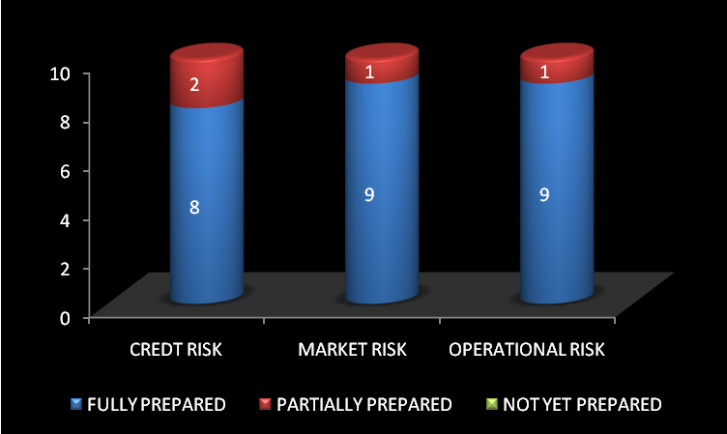
Figure 4.1.1 Readiness for the new Basel proposal

- Have you done a gap analysis between current risk management practice and new capital requirements?
Table 4.1.2: Gap analysis
 | CREDT RISK | MARKET RISK | OPERATIONAL RISK
YES | 9 | 5 | 9
NO | 1 | 5 | 1

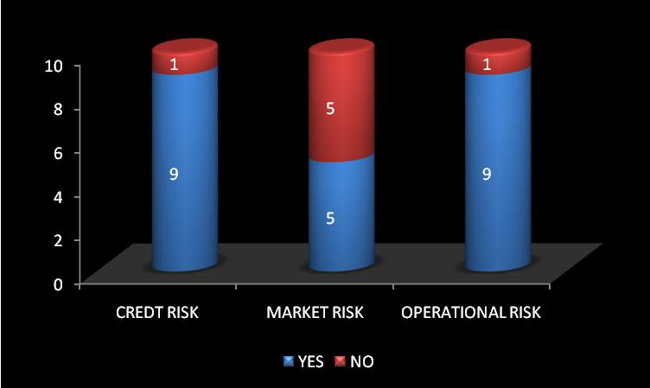
Figure 4.1.2 Gap analysis
- What degree of priority do you address to the new Basel regulatory framework?
Table 4.1.3: Priority to new Basel regulatory framework
 | CREDT RISK | MARKET RISK | OPERATIONAL RISK
VERY IMPORTANT | 9 | 9 | 10
IMPORTANT | 1 | 1
NOT IMPORTANT

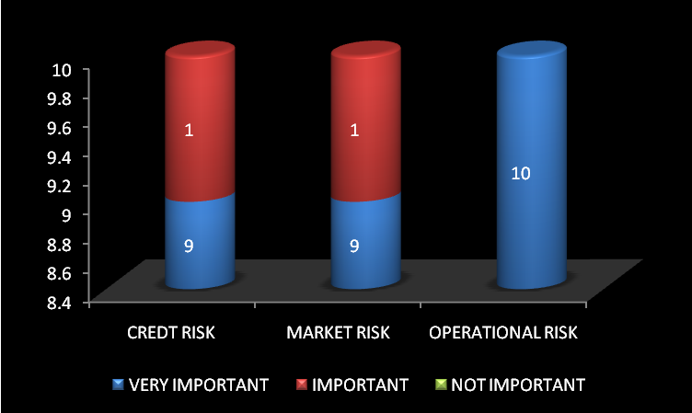
Figure 4.1.3 Priority to new Basel regulatory framework
- How do you view Basel II regulation: as an opportunity to enhance the risk management process, or as a regulatory constraint?
Table 4.1.4: View of Basel II regulation
 | CREDT RISK | MARKET RISK | OPERATIONAL RISK
OPPORTUNITY | 10 | 8 | 10
CONSTRAINT |  | 2

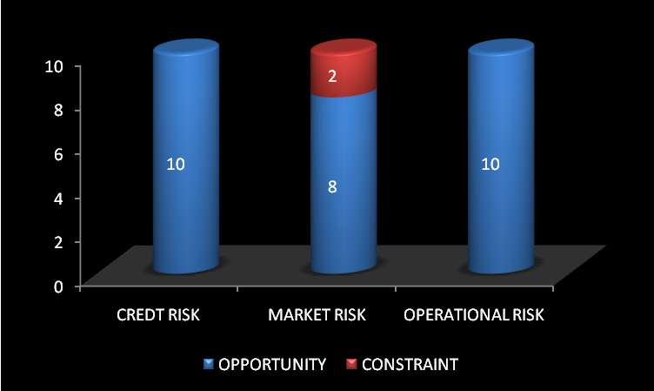
Figure 4.1.4: View of Basel II regulation
OBSERVATIONS

- The majority of banks consider themselves to be fully prepared.
- A majority of banks have performed a gap analysis between their current risk management practice and the new capital requirements.
- Only one bank does not view Basel II implementation as a high priority project.
- The banks largely believe that Basel II will provide them an opportunity to enhance risk management.
INTERPRETATION
- Although the Basel II regulations are considered important to very important by a strong majority of banks, some are only partly prepared for implementation.
- The banks aim to look beyond the regulatory aspects and aim to benefit from the new regulations as a means to enhanced risk management.

4.2 ORGANISTIONAL STRUCTURE

- Do you have an assigned Credit risk, Market risk and Operational risk manager in your bank?
Table 4.2.1: Assignment of risk manager
 | CREDT RISK | MARKET RISK | OPERATIONAL RISK
YES | 10 | 9 | 9
NO |  | 1 | 1

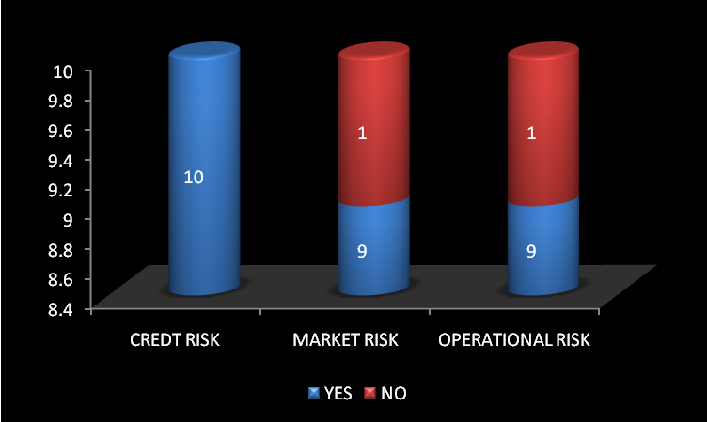
Figure 4.2.1: Assignment of risk manager

- To whom does the Risk manager report?
Table 4.2.2: Whom does risk manager report
 | CREDT RISK | MARKET RISK | OPERATIONAL RISK
CHIEF EXECUTIVE OFFICER | 4 | 6 | 6
CHIEF FINANCIAL OFFICER
ASSETS AND LIABLITY MANAGER | 2 | 1 | 1
CREDIT RISK OFFICER | 4 | 2 | 2
OTHER SPECIFY

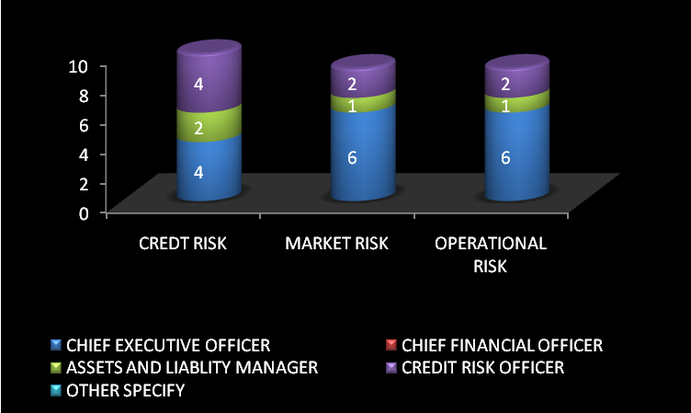
Figure 4.2.2: Whom does risk manager report?

- What is the assigned manager’s time dedicated to this activity?
Table 4.2.3: Time dedication
 | CREDT RISK | MARKET RISK | OPERATIONAL RISK
0-20% | 2 | 4 | 2
20-50% | 2 | 1 | 2
>50% | 6 | 5 | 6

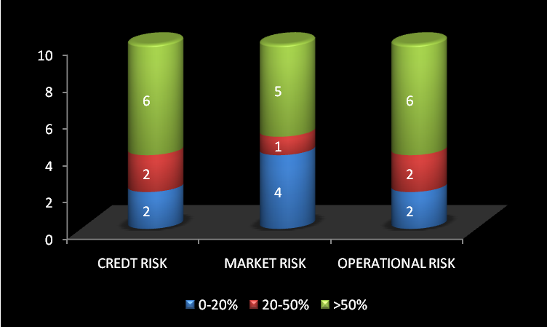
Figure 4.2.3: Time dedication
- How many people work in these departments?
Table 4.2.4: Number of people work
 | CREDT RISK | MARKET RISK | OPERATIONAL RISK
1 - 3 | 2 | 4 | 1
3 - 5 | 6 | 4 | 5
5- 10 | 1 | 1 | 1
> 10 | 1 | 1 | 3

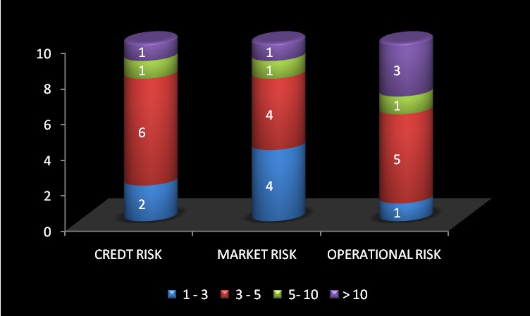
Figure 4.2.4: Number of people work
- Do you have a Risk Committee?
Table 4.2.5: Risk Committee
 | CREDT RISK | MARKET RISK | OPERATIONAL RISK
YES | 6 | 5 | 6
NO | 4 | 5 | 4

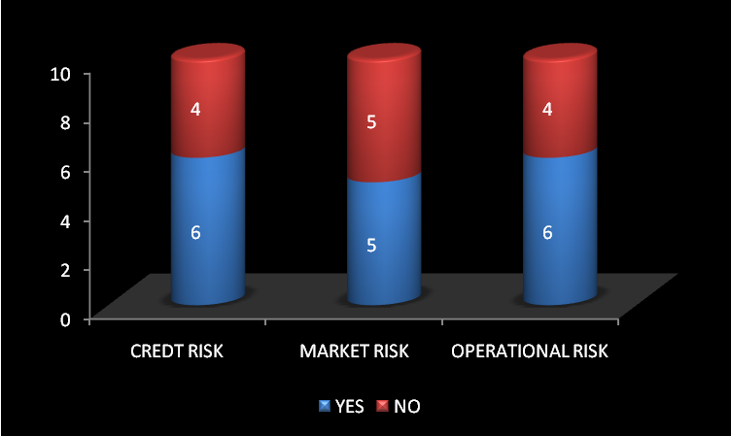
Figure 4.2.5: Risk Committee
OBSERVATIONS
- Almost all of the participating banks have a risk management departemnt.
- Most of the industry’s risk managers’ report to the Chief Executive Officer, Asset and liability manager and Chief Risk Officer accounting for the balance in equal proportions.
- Slightly more attention is paid to credit and operational risk than to Market risk, as 40 % of the banks operating do not have risk committee.

INTERPRETATION

- Despite the relatively small size of banks, they are generally well aware of the risk management function, and for this purpose, risk managers spend over half their time performing these functions.
4.3 REPORTING ABILITY

- Are you producing reporting for
Table 4.3.1: Reports produced for
 | CREDT RISK | MARKET RISK | OPERATIONAL RISK
REGULATORY PURPOSE | 3 | 4 | 4
MONITORING | 7 | 8 | 8
DECISION MAKING PURPOSE | 7 | 4 | 4

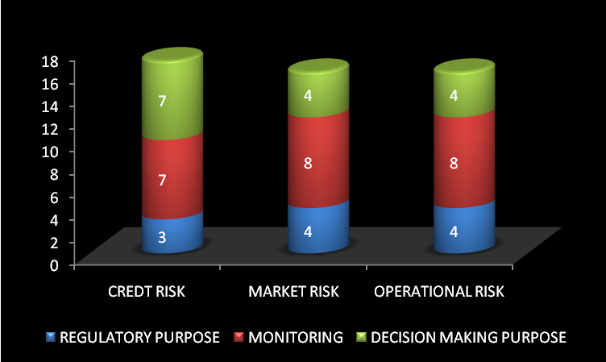
Figure 4.3.1: Reports produced for
- Does external reporting drive your internal reporting?
Table 4.3.2: External reporting drive internal reporting
 | CREDT RISK | MARKET RISK | OPERATIONAL RISK
VERY SIGNIFICANTLY | 4 | 5 | 4
SIGNIFICANTLY | 5 | 4 | 5
NOT AT ALL SIGNIFICANTLY | 1 | 1 | 1

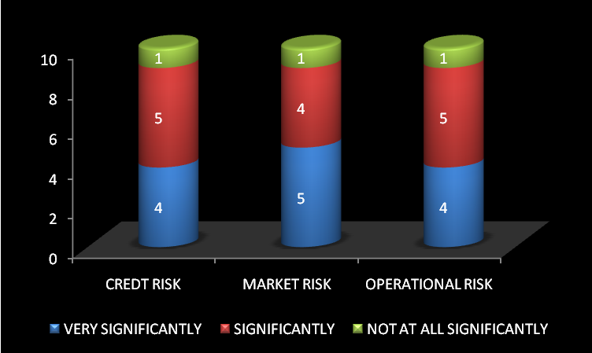
Figure 4.3.2: External reporting drive internal reporting
- Does external reporting affect your decision making process?
Table 4.3.3: External reporting affect decision making process
 | CREDT RISK | MARKET RISK | OPERATIONAL RISK
VERY SIGNIFICANTLY | 3 | 3 | 3
SIGNIFICANTLY | 6 | 5 | 6
NOT AT ALL SIGNIFICANTLY | 1 | 2 | 1

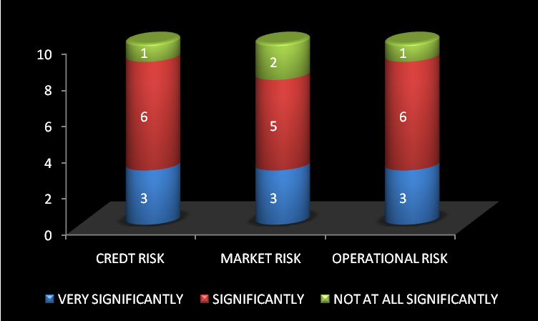
Figure 4.3.3: External reporting affect decision making process
- How frequent is your internal reporting?
Table 4.3.4: Frequency of internal reporting
 | CREDT RISK | MARKET RISK | OPERATIONAL RISK
Daily | 1 |  | 1
Weekly |  | 1 | 1
Monthly | 8 | 8 | 7
Annually | 1 | 1 | 1

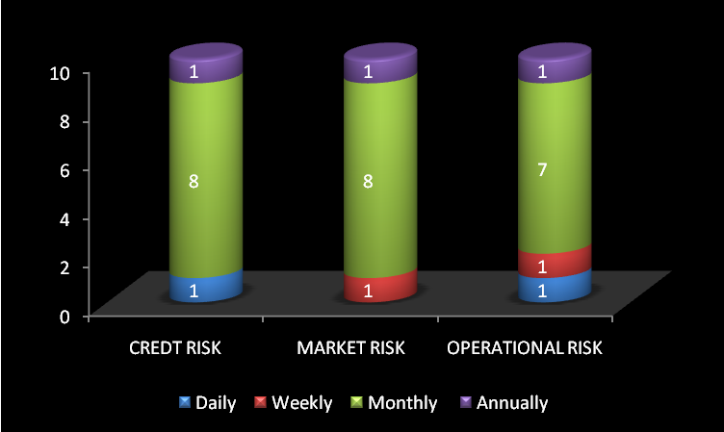
Figure 4.3.4: Frequency of internal reporting

- Will you produce specific internal reporting for Credit, Market and Operational Risk?
Table 4.3.5: Production of specific internal reporting
 | CREDT RISK | MARKET RISK | OPERATIONAL RISK
YES | 10 | 10 | 10
NO

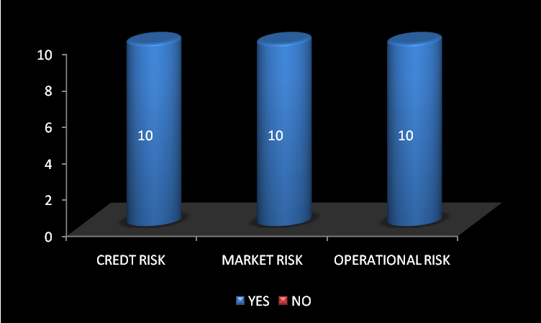
Figure 4.3.5: Production of specific internal reporting
OBSERVATIONS

- All risk reporting is compiled largely for monitoring and Decision making purposes than Regulatory purpose.
- All the Banks produce internal report.
- Most of the Banks produce Internal Report monthly.
- Most of the banks said External reporting affect their decision making process.

INTERPRETATION

- Reporting for all risk still needs to be developed.

4.4 COMPLIACE WITH BASEL II

- Which approach will best suit your organization?
Table 4.4.1: Approach that best suit organization
 | CREDT RISK | MARKET RISK | OPERATIONAL RISK
STANDARD | 8 | 9 | 7
FOUNDATION
ADVANCED | 2 | 1 | 3
DON’T KNOW

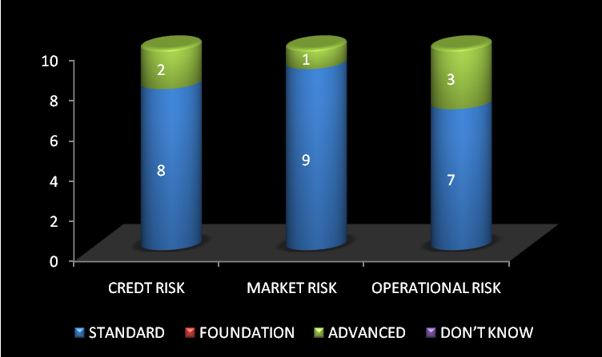
Figure 4.4.1: Approach that best suit organization

- Have you performed a Cost/Benefit analysis for each approach proposed by Basel II?
Table 4.4.2: Cost/Benefit analysis
 | CREDT RISK | MARKET RISK | OPERATIONAL RISK
YES | 10 | 8 | 9
NO |  | 2 | 1

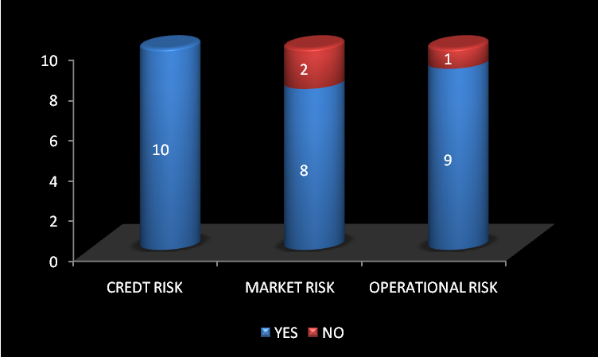
Figure 4.4.2: Cost/Benefit analysis
- In your situation, could regulatory capital consumption be motivation for:
Table 4.4.3: Regulatory capital consumption be motivation
 | CREDT RISK | MARKET RISK | OPERATIONAL RISK
STOPPING ACTIVITIES | 2 | 1 | 2
DEVEOPLING ACTIVITIES | 5 | 7 | 6
ACQUIRING ACTIVITIES | 1
NONE | 1 | 1 | 1

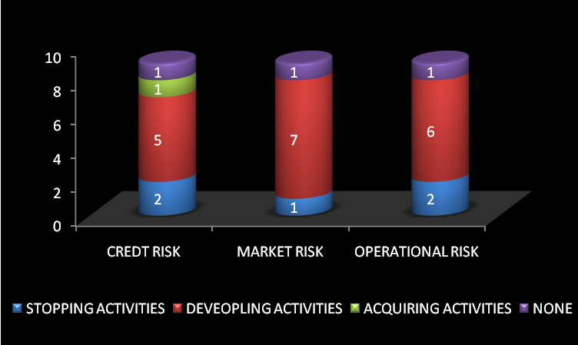
Figure 4.4.3: Regulatory capital consumption be motivation
OBSERVATIONS

- Most of the banks believe that the standard approach is most appropriate for their purposes.
- On the whole, a cost/benefit analysis has been done for each approach. It appears that the banks have completed their cost/benefit analysis only for their elected approach.
- Regulatory capital consumption is motivated for developing activities.

INTERPRETATION

- Most of the banks would prefer to adopt the standard approach, but only few of those who would like to implement the advanced approach and they will implement.
- The banks that would prefer to adopt the standard approach should try to adopt advanced approach.
4.5 CAPITAL ALLOCATION

- Have you estimated the regulatory capital consumption for each of your individual businesses?
Table 4.5.1: Estimation of the regulatory capital consumption
 | CREDT RISK | MARKET RISK | OPERATIONAL RISK
YES | 10 | 9 | 10
NO |  | 1

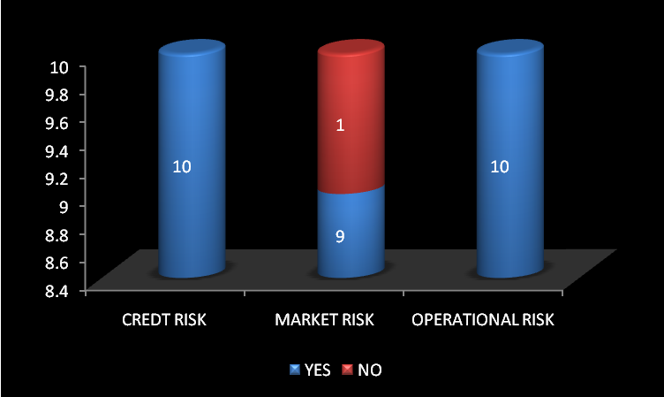
Figure 4.5.1: Estimation of the regulatory capital consumption

- Will you outsource activities with high capital consumption?
Table 4.5.2: Outsource activities for high capital consumption
 | CREDT RISK | MARKET RISK | OPERATIONAL RISK
YES | 4 | 3 | 5
NO | 6 | 7 | 7

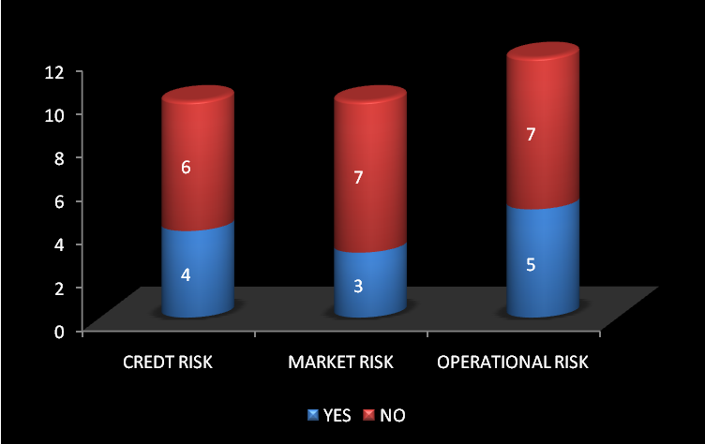
Figure 4.5.2: Outsource activities for high capital consumption
- Will you insure selected Risk?
Table 4.5.3: Insure Risk
 | CREDT RISK | MARKET RISK | OPERATIONAL RISK
YES | 7 | 5 | 6
NO | 3 | 5 | 4

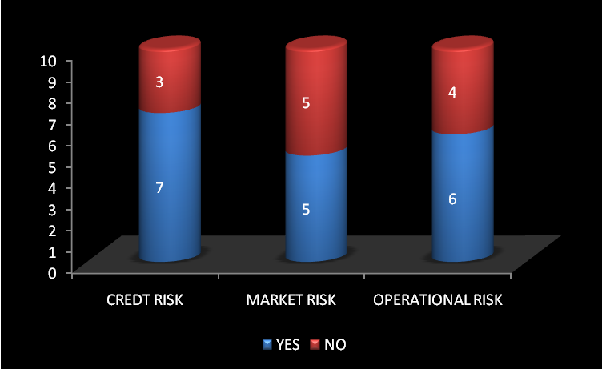
Figure 4.5.3: Insure Risk
- Do you intend allocating economic capital by Business lines?
Table 4.5.4: Allocation of economic capital
 | CREDT RISK | MARKET RISK | OPERATIONAL RISK
YES | 8 | 7 | 8
NO | 1 | 2 | 1

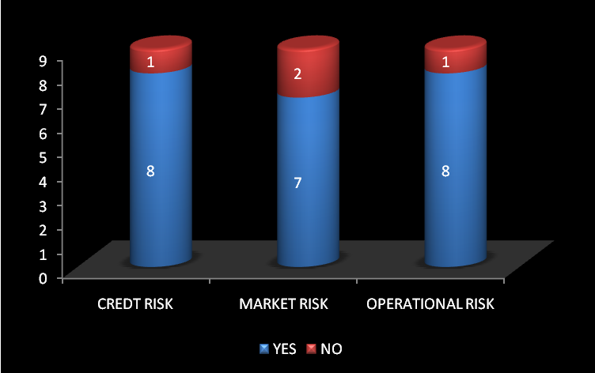
Figure 4.5.4: Allocation of economic capital

- Will you make use of Basel II requirements to implement an economic capital allocation throughout your business lines?
Table 4.5.5: Use of Basel II requirements
 | CREDT RISK | MARKET RISK | OPERATIONAL RISK
YES | 9 | 8 | 8
NO |  | 1 | 1

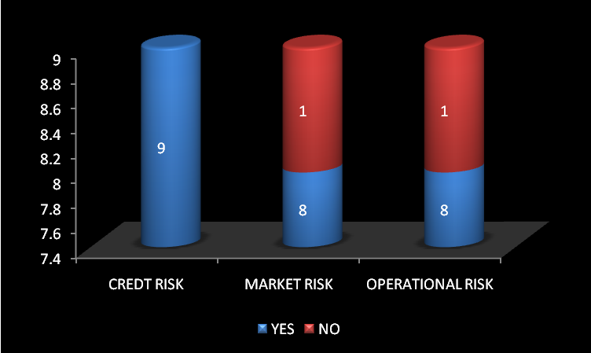
Figure 4.5.5: Use of Basel II requirements
OBSERVATIONS

- Most of the banks do not outsource activities with high capital consumption.
- Half of the banks insure selected Risk.
- Banks with less sophisticated approaches are likely to use regulatory capital as the basis for internal capital allocation.

INTERPRETATION

- Very few banks plan to outsource activities with high capital consumption, but the majority will insure their credit risks, while nearly half will plan to insure their market and operational risks.
- A strong majority of local banks will allocate economic capital according to business lines, while a stronger majority will use the Basel II requirements to implement that capital allocation process.
4.6 BASEL II ACTION PLAN

- Have you established an action plan to achieve the Basel II requirements?
Table 4.6.1: Establishment of action plan
 | CREDT RISK | MARKET RISK | OPERATIONAL RISK
YES | 10 | 10 | 10
NO

Figure 4.6.1: Establishment of action plan

- How will you execute this action plan?
Table 4.6.2: Execution of action plan
 | CREDT RISK | MARKET RISK | OPERATIONAL RISK
INTERNAL RESOURCES | 7 | 5 | 8
EXTERNAL RESOURCES | 1 | 4 | 1
BOTH | 4 | 3 | 3

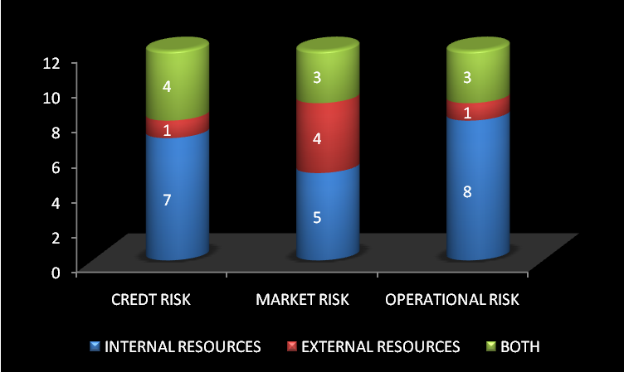
Figure 4.6.2: Execution of action plan
- What will the largest spending area be?
Table 4.6.3: Largest spending area
 | CREDT RISK | MARKET RISK | OPERATIONAL RISK
TECHNOLOGY | 8 | 7 | 8
COMMUNICATION | 1 | 4 | 1
OTHER (SPECIFY)
DON’T KNOW

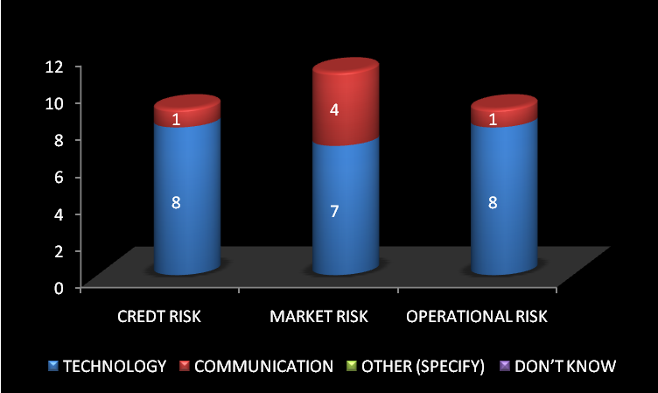
Figure 4.6.3: Largest spending area
- How far are you in the implementation of your action plan?
Table 4.6.4: Current progress
 | CREDT RISK | MARKET RISK | OPERATIONAL RISK
NOT REALLISED
PARTIALLY REALLISED | 5 | 7 | 5
FULLY REALLISED | 5 | 3 | 5

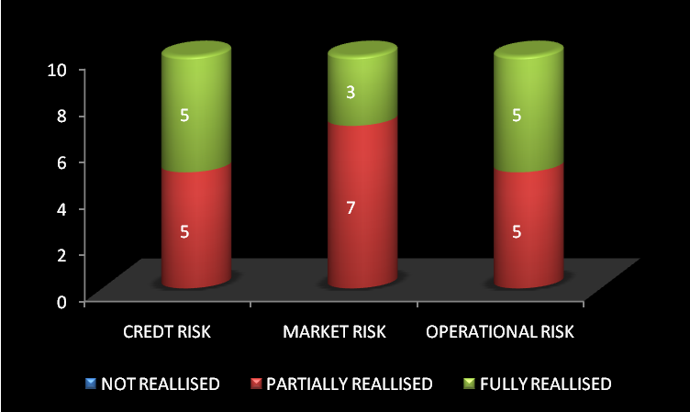
Figure 4.6.4: Current progress
OBSERVATIONS

- All the banks established by an action plan to achieve the Basel II requirements.
- Most of the banks execute the action plan with internal resources than external resources.
- Largest spending area is technology.
- Half of the bank’s implementation of action plan is partially realized and half fully realized.

INTERPRETATION

- The banks have generally determined an action plan to help them to meet Basel II requirements. They have partially completed the actions required, and will continue with these action plans.
- Those banks that have not yet begun implementation tend to be the smaller banks, with simpler business models, which require less time and resources to meet the Basel II requirements.

4.7 TECHNOLOGY

- Does your current IT infrastructure allow you to meet the Basel II requirements?
Table 4.7.1: IT infrastructure
 | CREDT RISK | MARKET RISK | OPERATIONAL RISK
YES | 10 | 8 | 9
NO |  | 2 | 1

Figure 4.7.1: IT infrastructure

- Will you develop an IT solution for Risk management?
Table 4.7.2: IT solution for Risk management
 | CREDT RISK | MARKET RISK | OPERATIONAL RISK
YES | 7 | 7 | 7
NO | 3 | 3 | 3

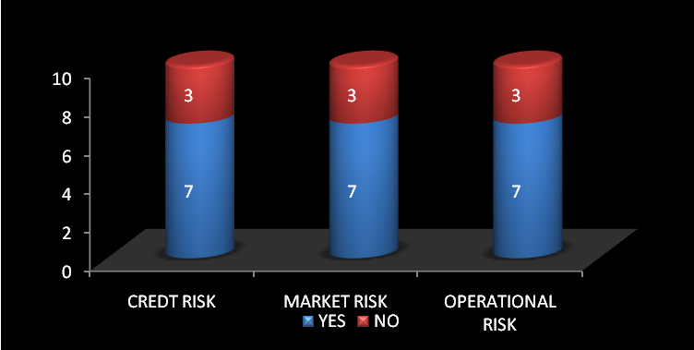
Figure 4.7.2: IT solution for Risk management

- Have you completed a review of potential IT solutions available?
Table 4.7.3: Review of potential IT solutions available
 | CREDT RISK | MARKET RISK | OPERATIONAL RISK
TECHNOLOGY | 5 | 3 | 4
CONSULTING | 4 | 6 | 5
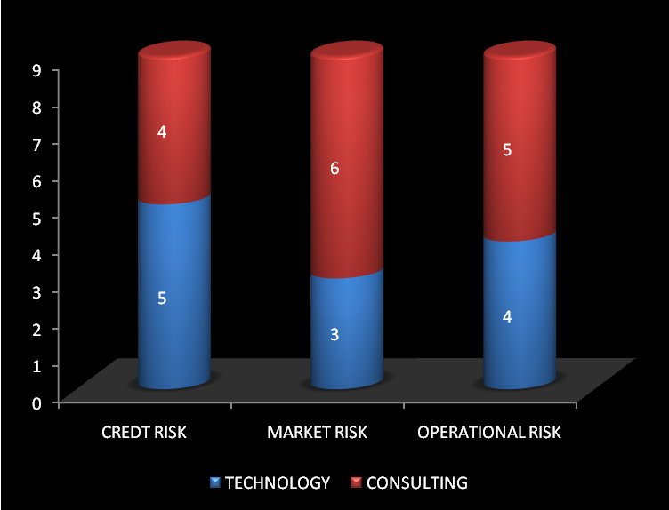
Figure 4.7.3: Review of potential IT solutions available

- What difficulties do you foresee?
Table 4.7.4: Difficulties that you foresee
 | CREDT RISK | MARKET RISK | OPERATIONAL RISK
INTEGRATION CAPABILITIES | 3 | 1 | 1
DATABASE DESIGN | 1 | 1
MODELS | 1 |  | 1
BUDGET |  |  | 1
DATA GATHERING | 4 | 6 | 4
HUMAN RESOURCE | 3 | 3 | 3
OTHER (SPECIFY)

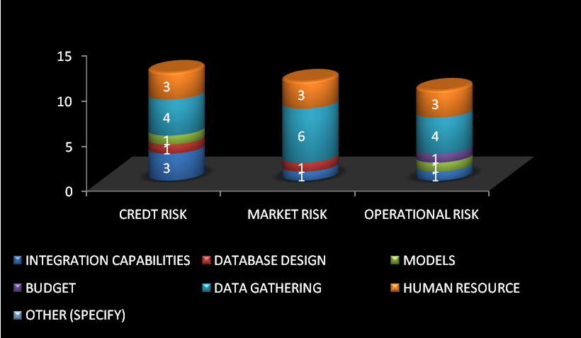
Figure 4.7.4: Difficulties that you foresee
OBSERVATIONS

- More than half of the Banking industry will use their IT infrastructure in its current format.
- Difficulties that banks foresee are more on Data Gathering and Human Resource.

INTERPRETATION

- The banks should train their employees, in order to overcome the difficulties in implementing the Basel II norms.
- The banks should develop sufficient infrastructure to gather the required data.

CHAPTER V
FINDINGS AND SUGGESTIONS

5.1 FINDINGS

- Credit risk is generally well contained, but there are still problems associated with loan classification, loan loss provisioning, and the absence of consolidated accounts.

- Market risk and Operational risk are clear challenge, as they are relatively new to the areas that were not well developed under the original Basel Capital Accord.

- The new regulations will allow banks to introduce substantial improvements in their overall risk management capabilities, improving risk based performance measurement, capital allocation as portfolio management techniques.

- Future complexity is expected because banks diversify their operations. It is expected that banks will diversify their operations to generate additional income sources, particularly fee-based income i.e. non interest income, to improve returns.

- Basel II leads to increase in Data collection and maintenance of privacy and security in various issues.

- The banks that would prefer to adopt the Standard Approach should try to adopt Advanced Approach.

5.2 SUGGESTIONS

- The Banks should review Basel II components and develop a vision, strategy and action plan for what is expected to be a suitable framework based on how the banking system evolves over time.

- The Banks need regular engagement for sustained support. A qualified long-term advisor would be preferable.

- A workshop should be planned to produce a road map to Basel II Compliance.

- Training and additional assistance to make it easier for the banking system to comply with new guidelines on market and operational risk.

- Data Privacy and security needs more attention

CHAPTER VI
CONCLUSION
6.1 CONCLUSION

Implementation of Basel II has been described as a long journey rather than a destination by itself. Undoubtedly, it would require commitment of substantial capital and human resources on the part of both banks and the supervisors. RBI has decided to follow a consultative process while implementing Basel II norms and move in a gradual, sequential and co-ordinate manner. For this purpose, dialogue has already been initiated with the stakeholders. As envisaged by the Basel Committee, the accounting profession too, will make a positive contribution in this respect to make Indian banking system still stronger.

CHAPTER VII
APPENDIX

7.1 QUESTIONNAIRE

I am BABASAB PATIL studying 4th semester MBA in BEC DOMS . I am working on a project titled “RISK MANAGEMENT IN BANKING SECTOR”. In this regard I request you to spend your valuable time in filling this questionnaire (Tick the appropriate box). This information will be used only for academic purpose and will be kept confidential.

INSTITUTIONAL INFORMATION
- Name of your bank:
- Please indicate the name of the contact person for this questionnaire and his/her position in the Bank. | Name:  Position:
- To which of the following types of banks does your bank belong? | - Public sector  - Private sector  - Foreign Bank
- Where is your parent/head office located?
Tick the appropriate box
AWARENESS OF REGULATIONS

1. What is your assessment of your readiness for the new Basel proposals with respect to capital requirements?
 | CREDT RISK | MARKET RISK | OPERATIONAL RISK
FULLY PREPARED
PARTIALLY PREPARED
NOT YET PREPARED
2. Have you done a gap analysis between current risk management practice and new capital requirements?
 | CREDT RISK | MARKET RISK | OPERATIONAL RISK
YES
NO

3. What degree of priority do you address to the new Basel regulatory framework?
 | CREDT RISK | MARKET RISK | OPERATIONAL RISK
VERY IMPORTANT
IMPORTANT
NOT IMPORTANT

4. How do you view Basel II regulation: as an opportunity to enhance the risk management process, or as a regulatory constraint?
 | CREDT RISK | MARKET RISK | OPERATIONAL RISK
OPPORTUNITY
CONSTRAINT

ORGANISTIONAL STRUCTURE

1. Do you have an assigned Credit risk, Market risk and Operational risk manager in your bank?
 | CREDT RISK | MARKET RISK | OPERATIONAL RISK
YES
NO

2. To whom does the Risk manager report?
 | CREDT RISK | MARKET RISK | OPERATIONAL RISK
CHIEF EXECUTIVE OFFICER
CHIEF FINANCIAL OFFICER
ASSETS AND LIABLITY MANAGER
CREDIT RISK OFFICER
OTHER SPECIFY

3. What is the assigned manager’s time dedicated to this activity?
 | CREDT RISK | MARKET RISK | OPERATIONAL RISK
0-20%
20-50%
>50%

4. How many people work in these departments?
 | CREDT RISK | MARKET RISK | OPERATIONAL RISK
1 – 3
3 – 5
5- 10
> 10

- Do you have a Risk Committee?
 | CREDT RISK | MARKET RISK | OPERATIONAL RISK
YES
NO

REPORTING ABILITY

1. Are you producing reporting for
 | CREDT RISK | MARKET RISK | OPERATIONAL RISK
REGULATORY PURPOSE
MONITORING
DECISION MAKING PURPOSE

2. Does external reporting drive your internal reporting?
 | CREDT RISK | MARKET RISK | OPERATIONAL RISK
VERY SIGNIFICANTLY
SIGNIFICANTLY
NOT AT ALL SIGNIFICANTLY

3. Does external reporting affect your decision making process?
 | CREDT RISK | MARKET RISK | OPERATIONAL RISK
VERY SIGNIFICANTLY
SIGNIFICANTLY
NOT AT ALL SIGNIFICANTLY

4. How frequent is your internal reporting?
 | CREDT RISK | MARKET RISK | OPERATIONAL RISK
Daily
Weekly
Monthly
Annually

5. Will you produce specific internal reporting for Credit, Market and Operational Risk?
 | CREDT RISK | MARKET RISK | OPERATIONAL RISK
YES
NO

COMPLIACE WITH BASEL II
1. Which approach will best suit your organization?
 | CREDT RISK | MARKET RISK | OPERATIONAL RISK
STANDARD
FOUNDATION
ADVANCED
DON’T KNOW

2. Have you performed a Cost/Benefit analysis for each approach proposed by Basel II?
 | CREDT RISK | MARKET RISK | OPERATIONAL RISK
YES
NO

3. In your situation, could regulatory capital consumption be motivation for:
 | CREDT RISK | MARKET RISK | OPERATIONAL RISK
STOPPING ACTIVITIES
DEVEOPLING ACTIVITIES
ACQUIRING ACTIVITIES
NONE

CAPITAL ALLOCATION

1. Have you estimated the regulatory capital consumption for each of your individual businesses?
 | CREDT RISK | MARKET RISK | OPERATIONAL RISK
YES
NO

2. Will you outsource activities with high capital consumption?
 | CREDT RISK | MARKET RISK | OPERATIONAL RISK
YES
NO

3. Will you insure selected Risk?
 | CREDT RISK | MARKET RISK | OPERATIONAL RISK
YES
NO

4. Do you intend allocating economic capital by Business lines?
 | CREDT RISK | MARKET RISK | OPERATIONAL RISK
YES
NO

5. Will you make use of Basel II requirements to implement an economic capital allocation throughout your business lines?
 | CREDT RISK | MARKET RISK | OPERATIONAL RISK
YES
NO

BASEL II ACTION PLAN

1. Have you established an action plan to achieve the Basel II requirements?
 | CREDT RISK | MARKET RISK | OPERATIONAL RISK
YES
NO

2. How will you execute this action plan?
 | CREDT RISK | MARKET RISK | OPERATIONAL RISK
INTERNAL RESOURCES
EXTERNAL RESOURCES
BOTH

3. What will the largest spending area be?
 | CREDT RISK | MARKET RISK | OPERATIONAL RISK
TECHNOLOGY
COMMUNICATION
OTHER (SPECIFY)
DON’T KNOW

Other (specify) ______________________________________________________________
4. How far are you in the implementation of your action plan?
 | CREDT RISK | MARKET RISK | OPERATIONAL RISK
NOT REALLISED
PARTIALLY REALLISED
FULLY REALLISED

TECHNOLOGY
1. Does your current IT infrastructure allow you to meet the Basel II requirements?
 | CREDT RISK | MARKET RISK | OPERATIONAL RISK
YES
NO

2. Will you develop an IT solution for Risk management?
 | CREDT RISK | MARKET RISK | OPERATIONAL RISK
YES
NO

3. Have you completed a review of potential IT solutions available?
 | CREDT RISK | MARKET RISK | OPERATIONAL RISK
TECHNOLOGY
CONSULTING

4. What difficulties do you foresee?
 | CREDT RISK | MARKET RISK | OPERATIONAL RISK
INTEGRATION CAPABILITIES
DATABASE DESIGN
MODELS
BUDGET
DATA GATHERING
HUMAN RESOURCE
OTHER (SPECIFY)

PLACE: __________________

DATE: Signature.

REFFERENCE
WEB SITES

- www.bis.org
- www.rbi.org
- www.kpmg.com
- www.cognizant.com
- www.google.com
- www.yahoo.com

BOOKS

- Hand Book on Risk management & Basel II norms

ARTICALS

- Risk Management in Banks. -- R S Raghavan Chartered Accountant.
- Basel Norms challenges in India –Swapan Bakshi
- White Paper The Ripple Effect: How Basel II will impact institutions of all sizes
- Risk Management Guidelines for Commercial Banks & DFIs.
- BASEL II – Are Indian Banks Going to Gain? -- Santosh N. Gambhire Jamanalal, Bajaj Institute of Management Studies Mumbai
- Basel II and India's banking structure C. P. Chandrasekhar and Jayati Ghosh

REPORTS

- Report on Implementing Basel II: Impact on Emerging Economies -- Jaydeep K. Thaker NMIMS
- Paper on Risk Assessment and Risk Management -- Santosh Deoram Watpade & Siddhi Shrikant Vyas MET’s Institute of Management Nashik.

